**Level 02**

### Customer Relationship Management Software (CRM)

**Team Quinary**

**Faculty of Information Technology University of Moratuwa**

**2022**

**Level 02**

### Customer Relationship Management Software (CRM)

#### Team Quinary

Team ‘Quinary’ Group Members

|  |  |
| --- | --- |
| Index No. | Name |
| 204053A | Fernando K.T.D. |
| 204233C | Wijesekara M.P. |
| 204039L | Dilanka M.G.G.H. |
| 204189E | Gunasena K.G.W.C. |
| 204183V | Samarakkody S.T.R.H.N. |

Supervisor

…......................................

Dr. Leelanga Senevirathna Department of Interdisciplinary Studies

**Faculty of Information Technology University of Moratuwa**

**2022**

### Contents

Contents 3

List of Figures 6

Chapter 1 - Introduction 8

* 1. Introduction 8
  2. Background and Motivation 9
  3. Aim and Objectives 10
  4. Problem in Brief 10
  5. Proposed Solution 11

Chapter 2 - Existing Solutions 13

* 1. Introduction 13
  2. Similar Products 13
     1. ClickUp 13
     2. HubSpot 14
     3. Pipedrive 15
  3. Summery 16

Chapter 3 - Technologies Adapted 18

* 1. Introduction 18
  2. Front-end technology 18
     1. React JS 18
  3. Back-end technology 19
     1. MS .net framework 19
  4. Database Technology 19
     1. Microsoft SQL server 20

Chapter 4 - Proposed Solution 21

* 1. Introduction 21
  2. Software Model 21
  3. Users, Activities, inputs, and outputs 22
  4. Process 24
  5. Our Approach 26
     1. Project Progress 26
     2. Survey Generation 26
     3. Payment Gateway 27
     4. Emails 27
     5. Notification system 27
     6. Chat system 27
  6. Project Management 27
  7. Summary 28

Chapter 5 – Analysis and Design 29

* 1. Use Case Diagram 29
  2. Activity Diagrams 30
  3. Class Diagram 33
  4. Sequence Diagrams 33
  5. ER Diagram 37

Chapter 6 – Implementation 38

* 1. Login page 38
  2. Administrator’s Dashboard 38
  3. Tech/ Project Lead’s Dashboard 39
  4. Customer’s Dashboard 39
  5. Add end user option (Update sales option in customer’s Dashboard) 40
  6. Payment detail view (in Customer Dashboard) 41
  7. Tech Lead’s Project detail view 42
  8. Customer’s Project detail view 42
  9. Administrator’s Customer Feedback Form responses option view 43
  10. Add user/project option 44
  11. Chat interface view 45

Chapter 7 - Discussion 46

* 1. Introduction 46
  2. Evaluation and testing 46
  3. How our solution differs from similar works done by others 46
  4. Further Work 46
  5. Summary 47

Chapter 8 – Reference 48

Appendix A - Individual Contribution 49

204053A - Fernando K.T.D 49

204233C - Wijesekara M.P 50

204039L - Dilanka M.G.G.H 51

204063E - Gunasena K.G.W.C 52

204183V - Samarakkody S.T.R.H.N. 53

Appendix B – Action Plan 54

### List of Figures

[Figure 01: Dashboard of ClickUp 14](https://uniofmora-my.sharepoint.com/personal/fernandoktd_20_uom_lk/Documents/L02S01/Software%20Project/08.%20Interim%20Evaluation/_Report/%23Interim%20Report%20v1.docx#_Toc123508757)

[Figure 02: Dashboard of HubSpot 15](https://uniofmora-my.sharepoint.com/personal/fernandoktd_20_uom_lk/Documents/L02S01/Software%20Project/08.%20Interim%20Evaluation/_Report/%23Interim%20Report%20v1.docx#_Toc123508758)

[Figure 03: Dashboard of Pipedrive 16](https://uniofmora-my.sharepoint.com/personal/fernandoktd_20_uom_lk/Documents/L02S01/Software%20Project/08.%20Interim%20Evaluation/_Report/%23Interim%20Report%20v1.docx#_Toc123508759)

[Figure 04: quick overview of the use cases and business structures for each CRM 16](https://uniofmora-my.sharepoint.com/personal/fernandoktd_20_uom_lk/Documents/L02S01/Software%20Project/08.%20Interim%20Evaluation/_Report/%23Interim%20Report%20v1.docx#_Toc123508760)

Figure 05: Use case Diagram 29

[Figure 06: Activity Diagram – Update Progress 30](https://uniofmora-my.sharepoint.com/personal/fernandoktd_20_uom_lk/Documents/L02S01/Software%20Project/08.%20Interim%20Evaluation/_Report/%23Interim%20Report%20v1.docx#_Toc123508762)

[Figure 07: Activity Diagram – Sign in 30](https://uniofmora-my.sharepoint.com/personal/fernandoktd_20_uom_lk/Documents/L02S01/Software%20Project/08.%20Interim%20Evaluation/_Report/%23Interim%20Report%20v1.docx#_Toc123508763)

[Figure 8: Activity Diagram Payment Reminders 31](https://uniofmora-my.sharepoint.com/personal/fernandoktd_20_uom_lk/Documents/L02S01/Software%20Project/08.%20Interim%20Evaluation/_Report/%23Interim%20Report%20v1.docx#_Toc123508764)

[Figure 9: Activity Diagram - Do Payments 31](https://uniofmora-my.sharepoint.com/personal/fernandoktd_20_uom_lk/Documents/L02S01/Software%20Project/08.%20Interim%20Evaluation/_Report/%23Interim%20Report%20v1.docx#_Toc123508765)

[Figure 10: Activity Diagram - Request Changes 31](https://uniofmora-my.sharepoint.com/personal/fernandoktd_20_uom_lk/Documents/L02S01/Software%20Project/08.%20Interim%20Evaluation/_Report/%23Interim%20Report%20v1.docx#_Toc123508766)

[Figure 11: Activity Diagram - Enter Sales Info 32](https://uniofmora-my.sharepoint.com/personal/fernandoktd_20_uom_lk/Documents/L02S01/Software%20Project/08.%20Interim%20Evaluation/_Report/%23Interim%20Report%20v1.docx#_Toc123508767)

[Figure 12: Activity Diagram - Survey Generation 32](https://uniofmora-my.sharepoint.com/personal/fernandoktd_20_uom_lk/Documents/L02S01/Software%20Project/08.%20Interim%20Evaluation/_Report/%23Interim%20Report%20v1.docx#_Toc123508768)

[Figure 13: Class Diagram 33](https://uniofmora-my.sharepoint.com/personal/fernandoktd_20_uom_lk/Documents/L02S01/Software%20Project/08.%20Interim%20Evaluation/_Report/%23Interim%20Report%20v1.docx#_Toc123508769)

[Figure 14: Sequence Diagram - Request Changes 33](https://uniofmora-my.sharepoint.com/personal/fernandoktd_20_uom_lk/Documents/L02S01/Software%20Project/08.%20Interim%20Evaluation/_Report/%23Interim%20Report%20v1.docx#_Toc123508770)

[Figure 15: Sequence Diagram - Login 34](https://uniofmora-my.sharepoint.com/personal/fernandoktd_20_uom_lk/Documents/L02S01/Software%20Project/08.%20Interim%20Evaluation/_Report/%23Interim%20Report%20v1.docx#_Toc123508771)

[Figure 16: Sequence Diagram - Survey Generation 34](https://uniofmora-my.sharepoint.com/personal/fernandoktd_20_uom_lk/Documents/L02S01/Software%20Project/08.%20Interim%20Evaluation/_Report/%23Interim%20Report%20v1.docx#_Toc123508772)

[Figure 17: Sequence Diagram - Show Payment Reminders 35](https://uniofmora-my.sharepoint.com/personal/fernandoktd_20_uom_lk/Documents/L02S01/Software%20Project/08.%20Interim%20Evaluation/_Report/%23Interim%20Report%20v1.docx#_Toc123508773)

[Figure 18: Sequence Diagram - Progress Update 35](https://uniofmora-my.sharepoint.com/personal/fernandoktd_20_uom_lk/Documents/L02S01/Software%20Project/08.%20Interim%20Evaluation/_Report/%23Interim%20Report%20v1.docx#_Toc123508774)

[Figure 19: Sequence Diagram - Do Payments 36](https://uniofmora-my.sharepoint.com/personal/fernandoktd_20_uom_lk/Documents/L02S01/Software%20Project/08.%20Interim%20Evaluation/_Report/%23Interim%20Report%20v1.docx#_Toc123508775)

Figure 20: ER Diagram 37

[Figure 21: Login Page 38](https://uniofmora-my.sharepoint.com/personal/fernandoktd_20_uom_lk/Documents/L02S01/Software%20Project/08.%20Interim%20Evaluation/_Report/%23Interim%20Report%20v1.docx#_Toc123508777)

[Figure 22: Dashboard - Admin 38](https://uniofmora-my.sharepoint.com/personal/fernandoktd_20_uom_lk/Documents/L02S01/Software%20Project/08.%20Interim%20Evaluation/_Report/%23Interim%20Report%20v1.docx#_Toc123508778)

[Figure 23: Dashboard - Tech Lead 39](https://uniofmora-my.sharepoint.com/personal/fernandoktd_20_uom_lk/Documents/L02S01/Software%20Project/08.%20Interim%20Evaluation/_Report/%23Interim%20Report%20v1.docx#_Toc123508779)

[Figure 24: Dashboard - Customer 39](https://uniofmora-my.sharepoint.com/personal/fernandoktd_20_uom_lk/Documents/L02S01/Software%20Project/08.%20Interim%20Evaluation/_Report/%23Interim%20Report%20v1.docx#_Toc123508780)

[Figure 25: End user management 1 40](https://uniofmora-my.sharepoint.com/personal/fernandoktd_20_uom_lk/Documents/L02S01/Software%20Project/08.%20Interim%20Evaluation/_Report/%23Interim%20Report%20v1.docx#_Toc123508781)

[Figure 26: End user Management 2 40](https://uniofmora-my.sharepoint.com/personal/fernandoktd_20_uom_lk/Documents/L02S01/Software%20Project/08.%20Interim%20Evaluation/_Report/%23Interim%20Report%20v1.docx#_Toc123508782)

[Figure 27: Payments 1 41](https://uniofmora-my.sharepoint.com/personal/fernandoktd_20_uom_lk/Documents/L02S01/Software%20Project/08.%20Interim%20Evaluation/_Report/%23Interim%20Report%20v1.docx#_Toc123508783)

[Figure 28: Payments 2 41](https://uniofmora-my.sharepoint.com/personal/fernandoktd_20_uom_lk/Documents/L02S01/Software%20Project/08.%20Interim%20Evaluation/_Report/%23Interim%20Report%20v1.docx#_Toc123508784)

[Figure 29: Project Details - Tech Lead 42](https://uniofmora-my.sharepoint.com/personal/fernandoktd_20_uom_lk/Documents/L02S01/Software%20Project/08.%20Interim%20Evaluation/_Report/%23Interim%20Report%20v1.docx#_Toc123508785)

[Figure 30: Project Details 1 - Customer 42](https://uniofmora-my.sharepoint.com/personal/fernandoktd_20_uom_lk/Documents/L02S01/Software%20Project/08.%20Interim%20Evaluation/_Report/%23Interim%20Report%20v1.docx#_Toc123508786)

[Figure 31: Project Details 2 - Customer 43](https://uniofmora-my.sharepoint.com/personal/fernandoktd_20_uom_lk/Documents/L02S01/Software%20Project/08.%20Interim%20Evaluation/_Report/%23Interim%20Report%20v1.docx#_Toc123508787)

[Figure 32: Feedback Form Results 43](https://uniofmora-my.sharepoint.com/personal/fernandoktd_20_uom_lk/Documents/L02S01/Software%20Project/08.%20Interim%20Evaluation/_Report/%23Interim%20Report%20v1.docx#_Toc123508788)

[Figure 33: Add Tech Lead 44](https://uniofmora-my.sharepoint.com/personal/fernandoktd_20_uom_lk/Documents/L02S01/Software%20Project/08.%20Interim%20Evaluation/_Report/%23Interim%20Report%20v1.docx#_Toc123508789)

[Figure 34: Add Customer 44](https://uniofmora-my.sharepoint.com/personal/fernandoktd_20_uom_lk/Documents/L02S01/Software%20Project/08.%20Interim%20Evaluation/_Report/%23Interim%20Report%20v1.docx#_Toc123508790)

[Figure 35: Add Project 44](https://uniofmora-my.sharepoint.com/personal/fernandoktd_20_uom_lk/Documents/L02S01/Software%20Project/08.%20Interim%20Evaluation/_Report/%23Interim%20Report%20v1.docx#_Toc123508791)

[Figure 36: Add Admin 44](https://uniofmora-my.sharepoint.com/personal/fernandoktd_20_uom_lk/Documents/L02S01/Software%20Project/08.%20Interim%20Evaluation/_Report/%23Interim%20Report%20v1.docx#_Toc123508792)

[Figure 37: Chat Bot 45](https://uniofmora-my.sharepoint.com/personal/fernandoktd_20_uom_lk/Documents/L02S01/Software%20Project/08.%20Interim%20Evaluation/_Report/%23Interim%20Report%20v1.docx#_Toc123508793)

### List of Tables

Table 01: User activities, inputs and Outputs 24

### Chapter 1 - Introduction

#### Introduction

A CRM system provides a main place where businesses can store customer’s and prospect data, track customer interactions, and share this information with colleagues. It allows businesses to manage relationships with customers, helping the business grow. With a CRM system in place, every question, every service request, every preference, and every past contact detail about every customer is instantly available, which means that every new interaction with them should always be personalized, relevant, and up to date.

Usually, the long-term existence and success of a business depend on the customer's attitude toward the business. So, maintaining a good relationship between them is necessary for the success of a company. To maintain a positive relationship between the client and the business, it is important to have a CRM (Customer Relationship Management) system. This platform engages the business by analyzing customer interactions and it includes marketing, reviews/ ratings of the business given by the customers, sales details, customer requirements, details of payments, newest updates of the company, etc.

As an example, the company can conduct a survey or distribute a form to get customer feedback and requirements through the CRM system and analyze these details. Also, the company can share significant moments (e.g., winning an award) with customers using newsletters easily through the CRM system. By using these features, CRM software can keep interacting with clients. When we consider the customers' point of view, clients also like to engage with the company frequently and continue to interact with them. So, the CRM system makes the company more valuable and successful by opening the path for vital communication.

#### Background and Motivation

Maintaining accurate data about customer interactions is important for a company. The company has a manually implemented all-interaction recording system that needs to be optimized to utilize it in a more efficient way. We developed CRM software to assist businesses in keeping customer contact information up to date, tracking every customer interaction, and managing customer accounts.

CRM software is an integrated suite of usual cloud applications, such as marketing cloud, sales cloud, and service cloud, that collects and stores customer data. It provides a centralized platform for sales teams to manage customer interactions and prioritize activities so that no customer feels ignored, thereby boosting their customer experience.

CRM software is one of the most important sales tools in a sales rep's arsenal. It is more than a contact management system. If used to its full capacity, a CRM allows sales reps to spend more time with customers and potential customers. The more time spent with customers, the more deals are closed, and the more loyal customers remain.

With our solution, we can directly connect with the customer and get their feedback about the services provided by the company. Then we can analyze the data provided and conclude about the customer satisfaction level, focusing on the projects that are available and contacting the employees working on their projects. They can also use our solution to get updates about their project and many more things from one place. So, for this purpose, a CRM solution would be great.

To motivate where the future of CRM is going, it will focus on simplicity, on getting data insights, and through effective human analysis, it will become easier to spot opportunities for improvement. This back-to-basics approach will help in the easy handling of all kinds of situations. It will have a trustworthy database. To have a successful journey, one must have a solid database that will help the company go. A proper CRM software solution will help a company build and maintain a good database. This database will be one of the most valuable assets of a company, and it can help them in the long run.

More Customer Engagement: CRM software will alert the right business practitioners to these conversations so they can act and engage. The technology might tell me when there is a selling prospect, a customer problem might be addressed, a competitor scenario might

hint at a business development opportunity or a market movement that may trigger a shift in business strategy.

Improved Customer Experience A good CRM software solution can help in improving the customer experience in every interaction. IT companies are producing strategic objectives like loyalty, advocacy, and customer lifetime value. An improved customer experience strategy is one of the most important developments a CRM can make. A Proper Survey of the Business Market A CRM software solution can run a regular survey of the business market. This makes it much easier for a company to thrive in the market. The latest trends and self-updating are the key steps for any business to grow better every day.

#### Aim and Objectives

**Aim:**

* + - To Develop Customer Relationship Management Software to manage customer interactions with the business.

#### Objectives:

* To keep record of Customer information and map them with the relevant projects.
* Keep record of Sales History and give updates about the ongoing projects.
* Send reminders about upcoming Payments and newsletters.
* To keep track of the payments made.
* To address the requests made regarding the projects.
* To track customer satisfaction regarding the work done.
* To generate detailed reports required for the company and customer regarding the project performance.
* Get Customer feedback

#### Problem in Brief

“To say that customer satisfaction is important is an understatement. In 2022, it is a necessity. According to Gartner, 81% of marketers view customer satisfaction as the main competition area in their industry. But the competitive edge is not all. According to PwC, 59% of customers will leave a company after several bad experiences, and 17% after one bad customer experience. Yes, this also concerns your previously loyal customers.

(“Customer Satisfaction: Why It’s Important in 2023 - Survicate”) And yes, they will not be back.”

All the businesses in the world are dependent on the revenue they make from selling products and providing services to customers. When considering the service providing businesses such as Health care, education, IT industry, customer satisfaction is a critical thing to be aware of. If the customer is not satisfied with the services provided by the Company, then the company is a failure, and it will be difficult to generate revenue. So, it is important to track customer satisfaction on a regular basis and make sure that the company is on the correct track.

For this purpose, we can use a CRM – Customer Relationship Management Software and from that we can directly connect with the customer and get their feedback about the services provided by the company and then we can analyze the provided data and conclude about the customer satisfaction level. Also, when considering the IT industry, the customer would like to directly contact the employees working on their project and to get updates about their project and many more things from one place. So, for this purpose, a CRM solution would be great.

#### Proposed Solution

The proposed solution is a CRM (customer relationship management) system to directly connect with the customers and get their feedback as inputs about the services provided by the company. After analyzing the data provided from the survey, the customer satisfaction level can be measured in relation to the software project that is provided by the company. The proposed solution includes a survey-generation system that allows users to customize the form and enter the necessary data. We have identified three main users of our system: customers, tech leads, and the administrator. All these parties can access the system by using their login profiles. It contains all contacts and gathers important customer information, like purchase records and previous messages across all projects, and makes it easily accessible to anyone in the company who needs it, and the customers can access all the records about the purchased project.

Also in the process view, the system will notify the customer about upcoming events such as payments, newsletters, and other required information. And the customer can directly make requests about changes through the system, which will be considered by the project managers, who will take the necessary actions as required. CRM software helps you track your relationship with existing and prospective customers. You can manage sales, follow up on marketing activities, and automate tasks (follow-ups and reporting) for better growth prospects.

And the team can easily collect and organize data about prospective and current customers using the CRM software’s dashboard and reporting features, which allow employees to automate and manage their pipelines and processes. The CRM can also help the tech lead evaluate corresponding project team members' performance, track their quotas and goals, and check their progress on each of their projects briefly. (“11 Benefits of CRM Systems - Business News Daily”)

The main functionalities and outputs of the proposed CRM are

* Customer and user information management
* Sales information and payment history
* Upcoming payment reminders
* Request additional support from the administration.
* Performance management with analysis tools
* Newsletters and Reports
* Survey generation and result dashboard

It gives an insight into the customer's needs and preferences, making way for tailored marketing and sales efforts for adequate growth. The best-fit CRM software helps you increase sales figures, get better customer satisfaction rates, and improve your efficiency in terms of processes and revenue. (“30 Top Software Ideas for Startups & SMEs for 2022

- PixelCrayons”) (“30 Top Software Ideas for Startups & SMEs for 2022 - PixelCrayons”)

### Chapter 2 - Existing Solutions

#### Introduction

Chapter 2 focuses on documenting the different approaches to addressing the same problem which this application selected to offer a solution for. In the modern world Customer relationship management (CRM) is a technology for managing all company's relationships and interactions with customers and potential customers. (“What is CRM? - Salesforce.com”) Furthermore, there are many applications dedicated to Customer relationship management (CRM) in the world too. This chapter describes related products in the market same as the proposed solution.

#### Similar Products

#### ClickUp

By combining data visualizations, marketing automation, messaging, and other features in one location, ClickUp makes it simple to manage and expand customer connections. Cross- functional teams like Marketing, Support Engineers, and Finance can use ClickUp to organize their duties and speed up the closing of deals because the features and tools are completely customizable. The features of ClickUp aid in boosting marketing and sales activities so that everyone has access to the information they require at the appropriate time. Better team dynamics and quicker task transfers to create a well-coordinated client experience are the outcomes.

Here are some additional ways to use ClickUp:

* + - * Customize ClickUp Workspace so teams and sales reps have the flexibility to view data in multiple ways.
      * Set up CRM templates for client deliverables and sales processes.
      * Build a sales forecasting model with historical data.

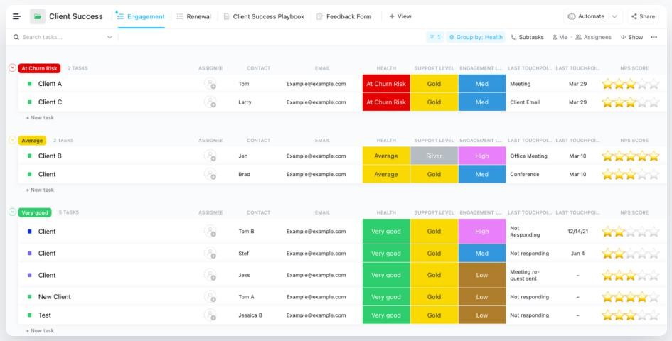

#### HubSpot

*Figure 01: Dashboard of ClickUp*

Providing inbound marketing and sales software, services, and education, HubSpot is a potent CRM solution. It provides a variety of products, such as HubSpot CRM, HubSpot Marketing, and HubSpot Sales, to assist organizations with their marketing and sales activities. Also, HubSpot includes an integrated analytics system offering users information on their marketing activities' effectiveness.

The HubSpot CRM can put sales teams in a better position to boost sales, increase customer engagement, and maximize their marketing efforts. To handle client interactions, a variety of functions are offered.

The business can simply manage interactions and data throughout the client lifecycle under one roof with a CRM platform like HubSpot. The website (HubSpot) may be used by businesses to build contact lists, monitor client interactions, and send out automated emails.

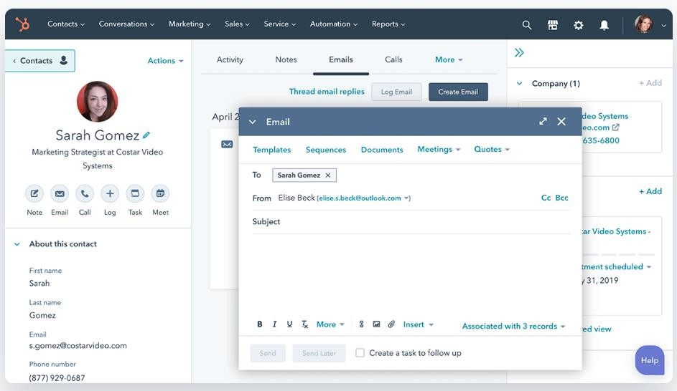

#### Pipedrive

*Figure 02: Dashboard of HubSpot*

A sales pipeline monitoring application called Pipedrive aids companies in tracking their sales cycle and success. It is the perfect cloud-based solution for businesses with remote sales staff because it can be accessed from any device. A few of the services that Pipedrive offers are sales integration, configurable pipelines, and email integration.

The sales process is shown graphically in a sales pipeline. The sales cycle's various stages, from prospect to customer, can be tracked.

In only three simple steps, Pipedrive makes it simple to build up a customized pipeline:

1. Create a pipeline by adding deals or automatically importing them from a CRM.
2. To keep deals moving forward, monitor progress via automatic alerts and reminders.
3. Automate growth using AI to find opportunities to close more sales.

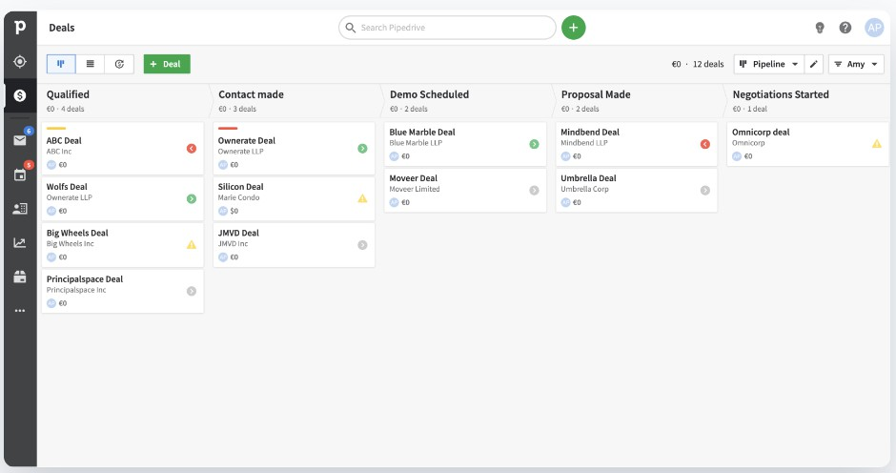

*Figure 03: Dashboard of Pipedrive*

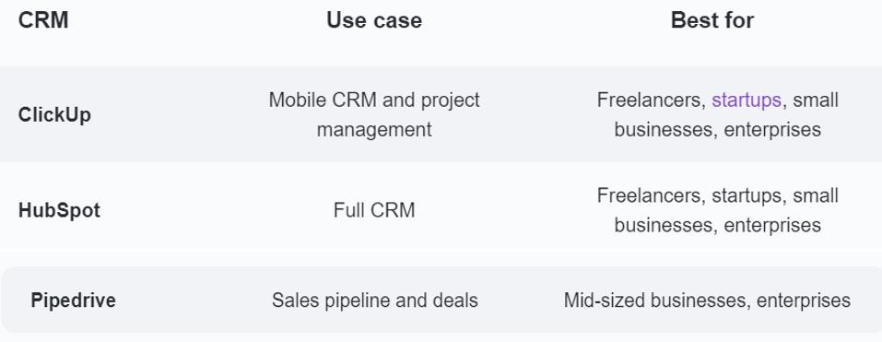

*Figure 04: quick overview of the use cases and business structures for each CRM*

#### Summery

According to the above research, there are similar features in CRM. In addition, our system demonstrates the following unique features,

* Very simple user interface.
* Survey generation and result dashboard.
* Performance management.
* Newsletters and Reports.
* Upcoming payment reminders.

It gives an insight into the customer needs and preferences, making way for tailored marketing and sales efforts for adequate growth. The best fit CRM software helps increase sales figures, get better customer satisfaction rates, and improve efficiency in terms of process and revenue. (“30 Top Software Ideas for Startups & SMEs for 2022 - PixelCrayons”)

### Chapter 3 - Technologies Adapted

#### Introduction

To build the proposed solution, various technologies are used. They can be divided into the following categories.

* + - Front-end technology
      * React JS
    - Back-end technology
      * MS .net framework
    - Database technology
      * MS SQL Server

#### Front-end technology

The front-end is the interfaces within the proposed system. And this is the point at which end users engage with the system. The system needs to provide a better user experience through interfaces from the viewpoint of the end user. Therefore, we have selected React JS to develop the front-end.

#### React JS

React is a popular JavaScript library for building user interfaces, particularly web-based applications. It is often used for front-end development because it allows developers to create reusable components that can be rendered on the page, making it easier to build and maintain complex user interfaces. Since the proposed system is CRM software, there are so many individual sections that should be attached together and reused. The functionality of React may be a huge advantage while the development of front-end.

One of the key benefits of React is that it uses a virtual DOM (Document Object Model). Therefore, when data in a React application changes, the virtual DOM will determine the minimal set of changes that need to be made to the actual DOM. This could lead the application to improve the performance.

React also has a strong developer community, with a wealth of resources and libraries available to help developers build and maintain their applications. Since the team members

do not have a lot of experience of building front ends and using react for development, this can be a main benefit for the team.

Due to the efficiency, flexibility, and strong developer community of React, it is easier to build the front-end of the proposed system.

#### Back-end technology

All the functionalities of the proposed system are within the back-end development. And it is the core of the application. Therefore, back-end technology is selected carefully. That is why Microsoft .net Framework is selected to build the back end of the system.

#### MS .net framework

The .NET framework is a popular choice for back-end development because it provides a powerful platform for building and running web-based applications and services. Also, it is flexible and scalable, allowing developers to build applications for a wide range of environments and platforms.

One of the key benefits of the .NET framework is that it provides a large set of libraries and APIs that developers can use to access a variety of different services and resources. This includes support for networking, data access, security, and many other common back- end tasks.

The .NET framework also includes several tools and technologies that make it easier for developers to build and maintain applications, including a powerful runtime environment, a comprehensive set of development tools, and a large and active developer community.

#### Database Technology

The database can be identified as a major entity of the system. A database is typically designed to store and access data. A well-designed database is crucial to the system since the database stores all the relevant insights regarding the system. To develop such a database, the team has decided to use Microsoft SQL server as the technology.

#### Microsoft SQL server

SQL server has been introduced and maintained by Microsoft so far. Because of its popularity and many other facts, it is widely used as a Database Management System (DBMS) by many developers. Also, it is compatible with .net framework too.

Some of the features of SQL server are,

**Reliability:** Reliability and uptime of SQL server is making it an excellent choice for mission-critical applications that require a high level of availability.

**Performance:** SQL Server is designed to handle large volumes of data and transactions, and it is optimized for fast and better performance.

**Security:** There are many security features to protect data from unauthorized access, such as encryption, authentication, and access controls within SQL server.

**Scalability:** This allows us to handle increasing amounts of data and workloads as the needs of the application grow.

**Management:** Handy features like backup and recovery, monitoring, and performance tuning can be used within SQL server.

### Chapter 4 - Proposed Solution

#### Introduction

Our system, CRM software, will be used to manage customer requests and customer relations related to a certain company. Through the software, we try to provide an interface for the customer to connect with the administration and the project lead of their specific project and through that make it easy for the customer to connect with the project managers efficiently.

Here the customer can track the real time progress of the project and rate the project progress and through that, the company can measure customer satisfaction and take necessary steps accordingly.

In addition, the customer can easily inform the requirement changes to the company and then the developers can assess them and accept or reject the request accordingly. In addition to that, this system will send payment reminders and newsletters to the customers. Here we have provided the facility to make the payments too and then the system will track the payments and sales history of the software.

#### Software Model

We are using the Agile Scrum model to develop the system. Since the user requirements have a possibility to change and we would have a ready to ship model after every scrum, we have a good chance to get the user’s idea about the project and deliver what the customer expects well.

Also on the other hand, we will be working with the industry, and we will be able to get hands on experience of how Agile Scrum method will be used in the industry which would be useful for our future career, since agile scrum is one of the widely used software models in modern tech world.

#### Users, Activities, inputs, and outputs

|  |  |  |
| --- | --- | --- |
| Users |  | |
| Customer | Activities | * Login using username and password * Check project progress * Do payments * Request changes * Update sales information * Receive newsletters * Receive payment reminders * Give feedback about the progress * Analyze the project progress * Edit user details * View balance payment details |
| Inputs | * Username and Password * Change requests * Payments * Feedback * Sales information |
| Outputs | * Project progress * Payment reminders * Newsletters * Project progress analyze charts |
| Administrator | Activities | * Login using username and password * Create customer account * Create the project page and connect it with customer * Address the requirement change requests * Assign a project lead |

|  |  |  |
| --- | --- | --- |
|  |  | * Review customer feedback * Update project progress * Generate surveys * Reactivate projects * Update payment history * View payment history * View balance payment details * Generate reports * Make newsletters * View sales history |
| Inputs | * Username and Password * Newsletters * Payment details * Surveys * Reports * Add customer * Add project and connect it with customer |
| Outputs | * Customer survey results * Monthly project progress * Due payments * Payment history * Accept or Reject customer requests * After sales information * Customer satisfaction charts |
| Project Lead | Activities | * Login using username and password * Address the requirement change requests * Review customer feedback * Update project progress * Generate surveys |

|  |  |  |
| --- | --- | --- |
|  |  | * Generate reports * Edit profile details * View payment history * View balance payment details * Generate newsletters * View sales history |
| Inputs | * Username and Password * Project progress * Accept/reject customer requests * Surveys * Reports * Newsletters |
| Outputs | * Customer requests * Payment history * Due payments * After sales information * Customer survey results * Customer satisfaction charts |

*Table 01: User activities, inputs, and Outputs*

#### Process

Our software will manage the customer relationships regarding each project. Firstly, a new customer will be registered to the application by entering the required data. This registration is done by the administration. Then at the same time, a project page for the project will be created and it will relate to the customer’s account.

When the customer logins to the system each project of the customer will be available as a list and he/she can select the required project, enter the page, and refer to the required information from the project page. The project page will consist of a project progress dashboard, which will carry all the real-time updates about the ongoing project. Then the customer can also make a requirement change request through the chat system provided

and then the administration and project lead will assess the request and accept or reject it accordingly. The acceptance or rejection of the requirement will be informed to the customer through the chat interface provided in the system. If the requirement is accepted, the administration or project lead can proceed with further requirements with the client and take necessary steps to implement the requirement for the ongoing project.

The project’s progress will be updated by the lead or team and then displayed for the customer’s reference in the project progress dashboard. For this, we are trying to integrate the company’s project management tool with our system and then connect the projects with each other and provide real time updates about the project as it gets updates in the project management tool of the development side.

In addition to that, the customer will be notified about the due payments prior to one month and then the customer can make a payment through the payment gateway provided or discuss with the administration and extend the payment period. If the payment is not done correctly on time, the system will deactivate the software service and then the user will not be able to use it. In such a situation, only the administration personnel can reactivate the system for the customer side. All system users can view the payment history and due payments of a project. In addition, the customer will receive the newsletters via email.

At the end of each month, the administration and project lead will collaboratively generate a survey with a unique set of questions for the customers to get customer feedback on certain criteria about the project. These surveys will be sent to the customer each month and after the customer fills out the survey the results will be compared with the previous month’s feedback and used for the decision-making process. Here we consider the feedback as the customer’s satisfaction about the projects progress and through that, we can conclude if the customer is satisfied with the phase of the project completion or not.

The customer can buy the product and resell the product to end customers. When reselling the product, the customer must provide the end customer's details to the system through the form provided and update the details. Through that, the developers can track the end user details of the system.

Finally, the administration has the power to remove the customers and project leads accounts from the system as they finish the allocated workload.

#### Our Approach

In our software, one of the basic ideas is to provide real time updates about the project for the customers, take feedback about the progress from the customer, analyze them, and provide a report about customer satisfaction at the end of each month based on the customer feedback form.

We are using React JS as the frontend technology and then .NET as the Backend technology. By using these technologies, it would be easy for us to design the UI and database transactions easily. Apart from that, we need to update the real-time updates about the project and display them to the customers using the interface provided. The below technologies will be used to address each module

#### Project Progress

For this purpose, we would integrate the project management software used by the company to maintain the projects. We need to join the specific project with the client’s project and through that we can get real time updates about the project progress as the developer edits the project management tool. By using this method, the developer will benefit as he or she will not need to update the same thing twice and just by a single update, we can do the changes in both places.

#### Survey Generation

We need to create a form in the end of each month so that we can get the customer feedback about the project progress and by that, we can check the customer satisfaction and we need to analyze it and create a report according to the present and previous data available. Each month the customer will be given a form with a unique set of questions about the project’s progress, and he/she can rate it. In addition, by comparing the data we can conclude about customer satisfaction and check if it has progress or not by the charts provided, this will benefit the company to get an idea about the customer’s mindset about the project progress.

For the creation of Forms, we can integrate Google forms to our software or as for the requirement, we need to create a similar product where we can create and save forms. If we are to integrate Google forms, it will help us in analyzing part as it generates the charts by itself automatically.

#### Payment Gateway

To use a payment gateway in the system to facilitate online payments we would integrate a payment gateway to the system and then use it to do the payments. For this purpose, we can use a payment gateway such as PayPal, or a similar trusted product recommended by the client. By using a payment gateway, it will ensure the security and accuracy of the transactions and as developers; we would not require ensuring security of the payments again.

#### Emails

For the task of sending newsletters and payment reminders, we will use emails to send the newsletters and payment reminders. Each month, a scheduled newsletter will be delivered to the customer and a payment reminder sent to them one month before the payment date.

#### Notification system

The system will have a notification system to notify the important things when a user logs in to the system. Usually, the customer will be notified about a payment reminder and monthly surveys. The other users will be notified about the requirement change requests made by the customer and about the results of the customer surveys.

#### Chat system

This is the basic system used to communicate in the system. The customer can communicate with the administration or project lead about the project’s progress and the main idea of this module is to communicate the customer’s requirement change requests easily and efficiently to the required parties.

#### Project Management

To approach a successful product, we follow a project management plan. A formal, approved document defines how our project is executed, checked, and controlled. We are working according to our management plan, and we used Jira software to increase the management. Our project management plan is attached under Appendix B.

We use Jira to assign tasks among the group members, set due dates, and share documents. That software is a little bit like our proposed solution. We create our task boards with

different columns and move the tasks between them. Columns include task statues such as To Do, In Progress, Done.

#### Summary

This chapter provides an overall idea of our proposed solution, users, input, output, and technology of our system. In addition, we describe the software process model and the methods we use to address the problems of other modules we used.

### Chapter 5 – Analysis and Design

#### Use Case Diagram

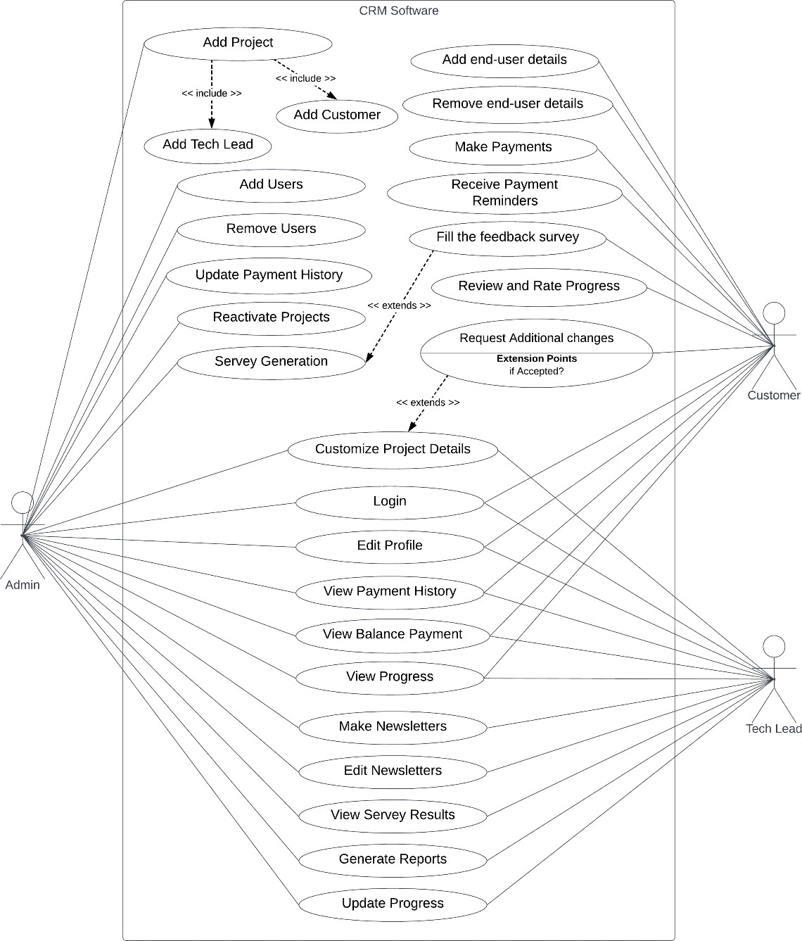

*Figure 05: Use case Diagram*

#### Activity Diagrams

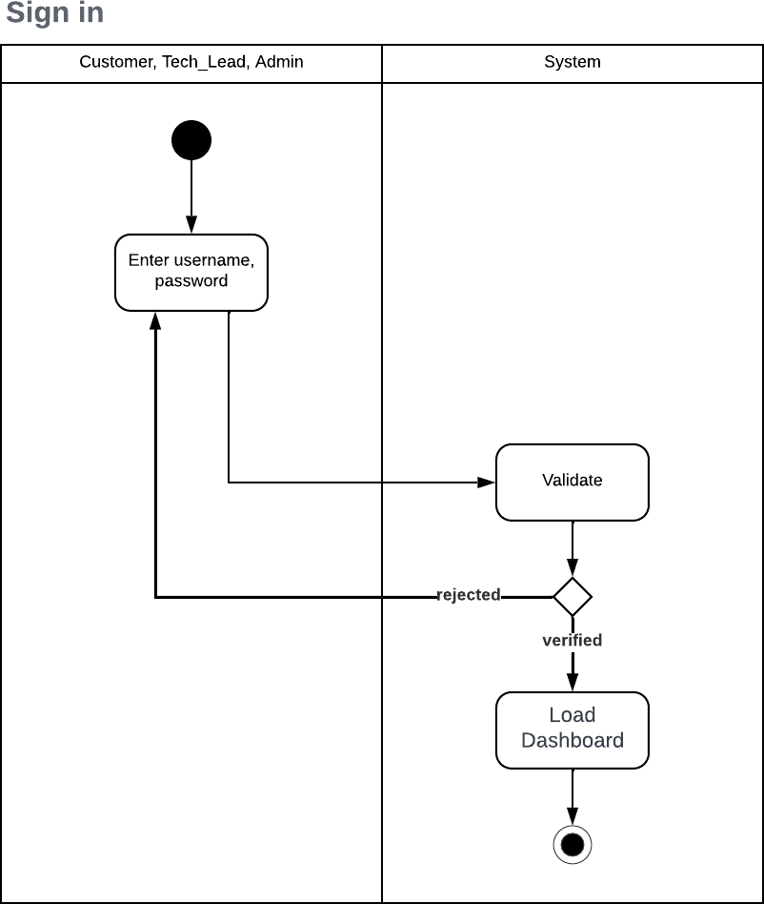

*Figure 07: Activity Diagram – Sign in*

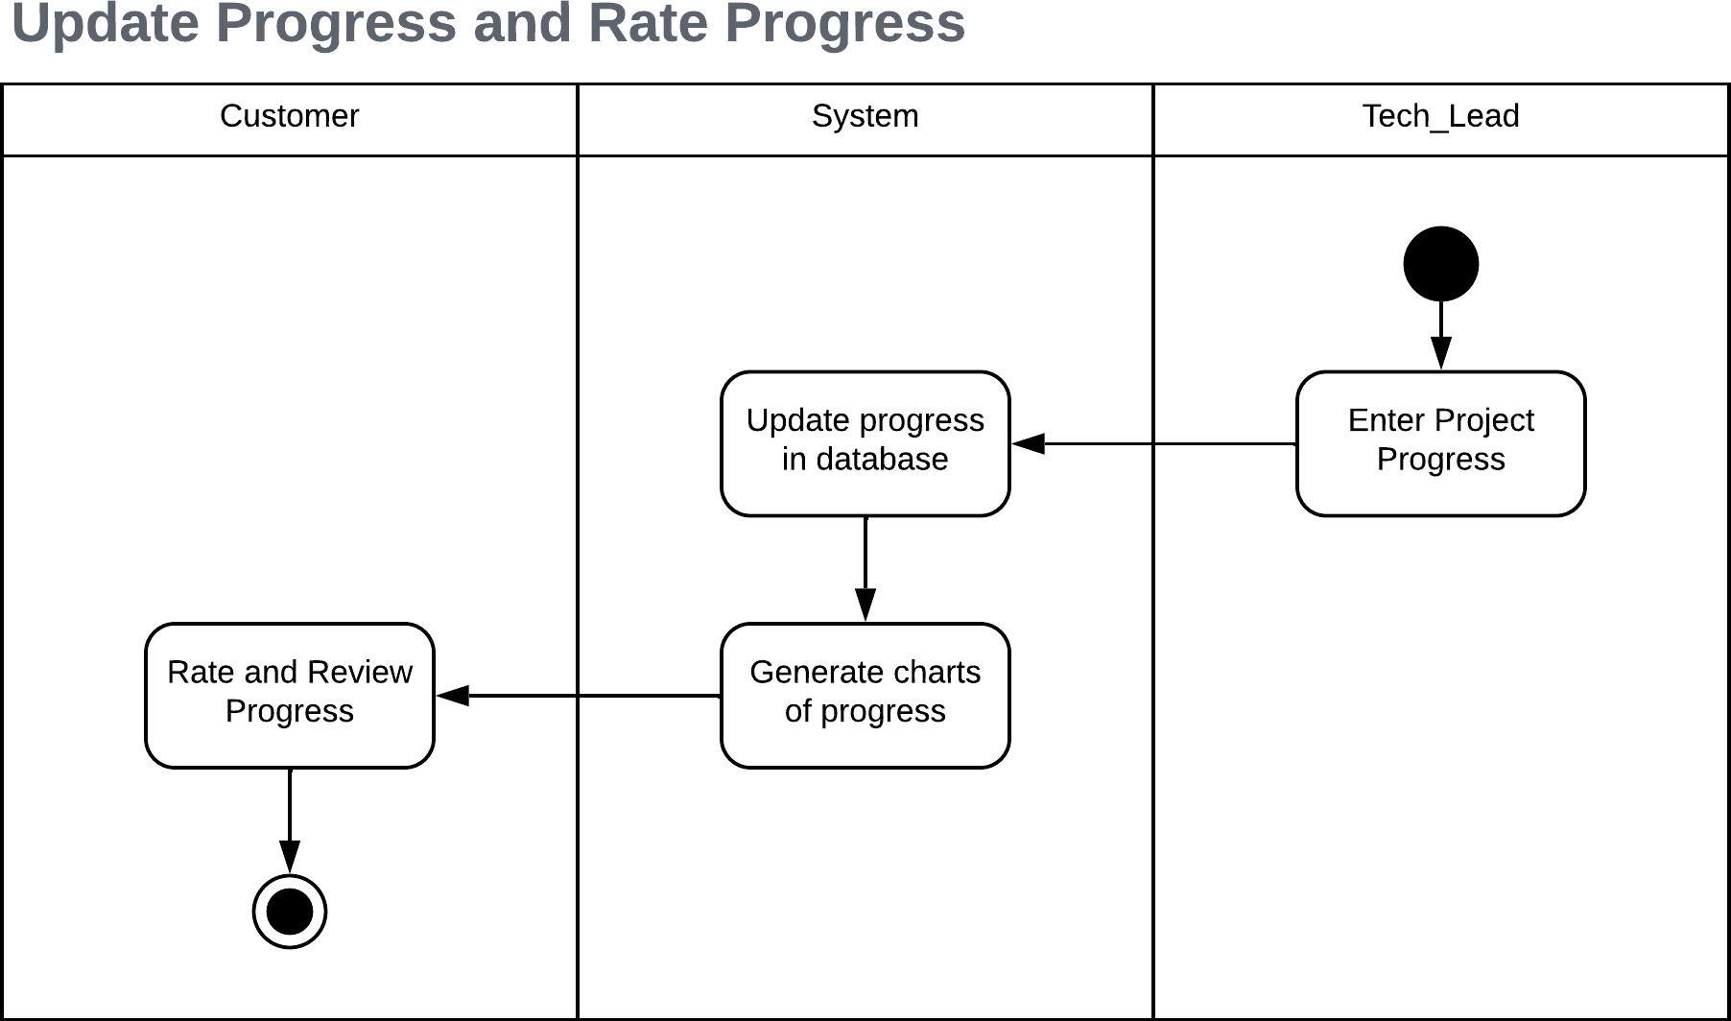

*Figure 06: Activity Diagram – Update Progress*

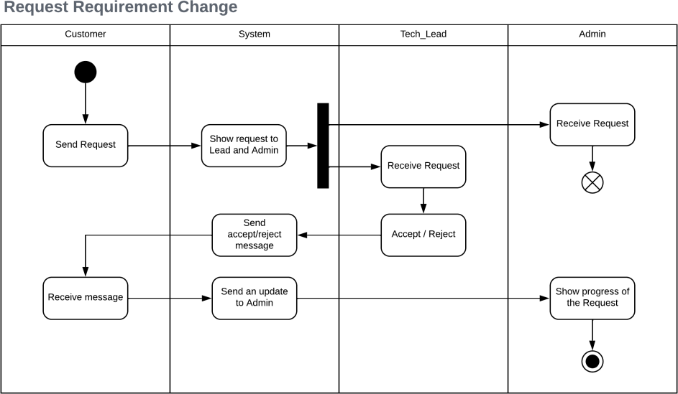

*Figure 10: Activity Diagram - Request Changes*

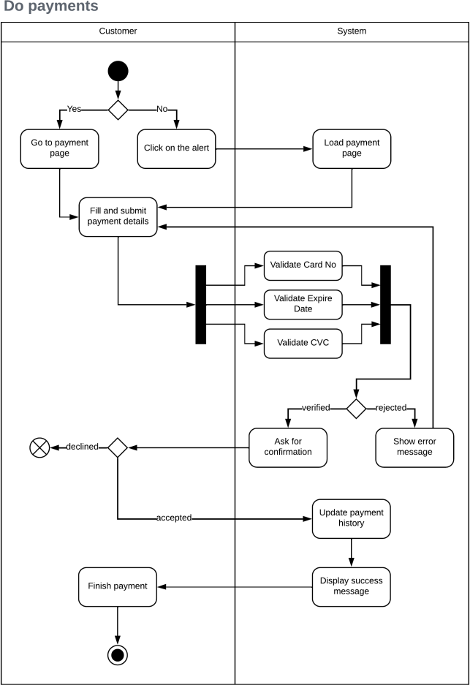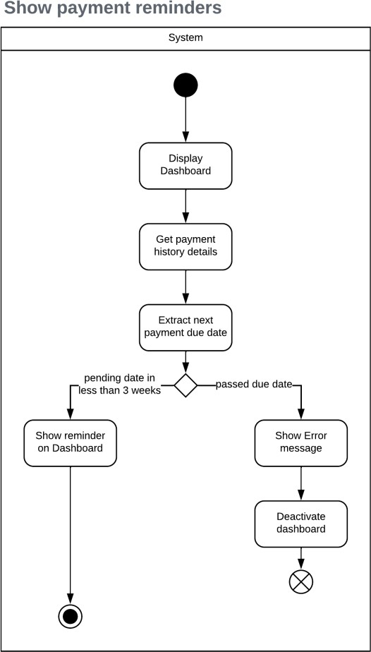

*Figure 9: Activity Diagram - Do Payments*

*Figure 8: Activity Diagram Payment Reminders*

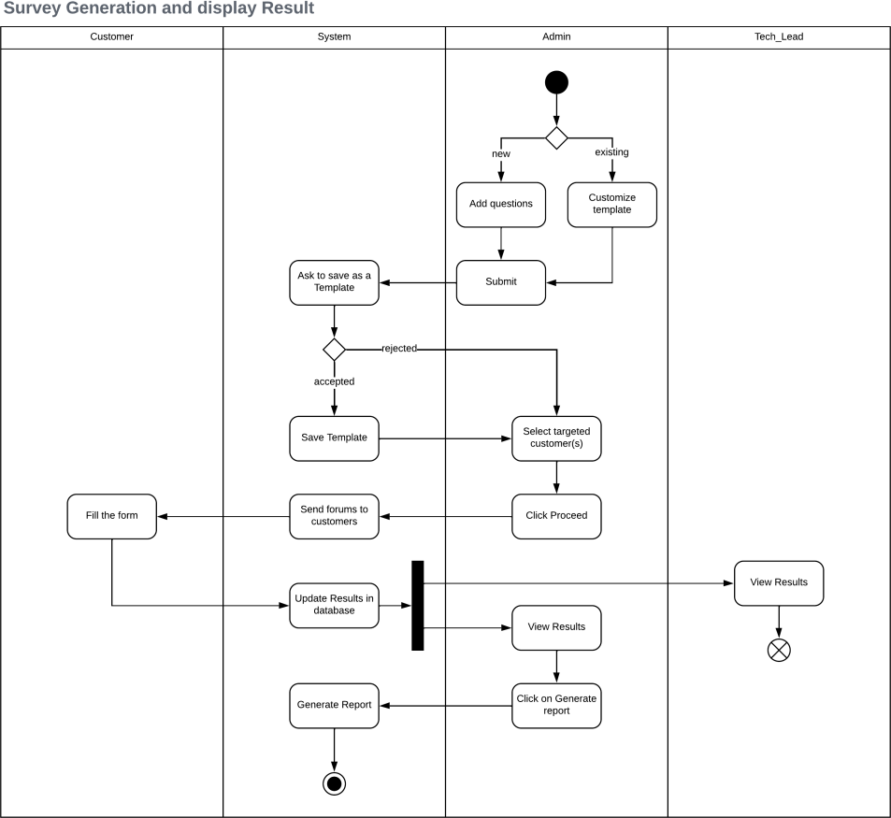

*Figure 12: Activity Diagram - Survey Generation*

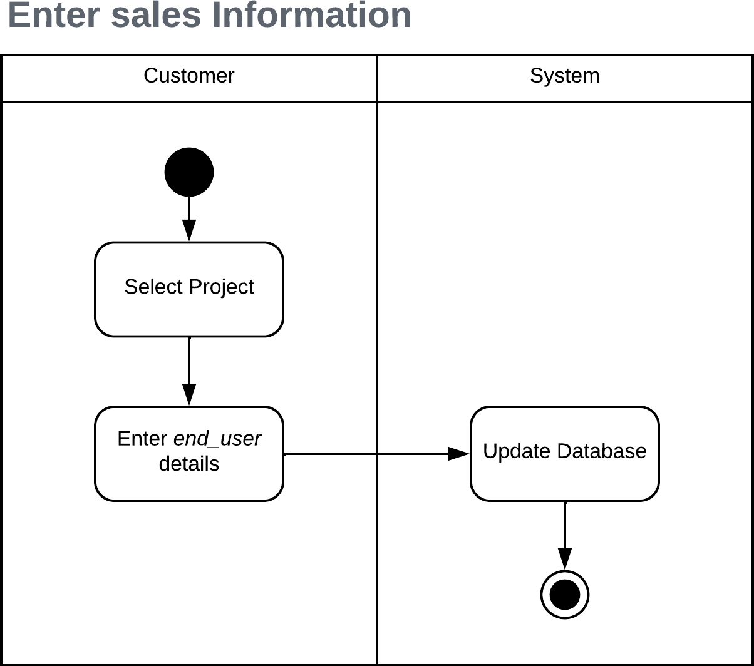

*Figure 11: Activity Diagram - Enter Sales Info*

#### Class Diagram

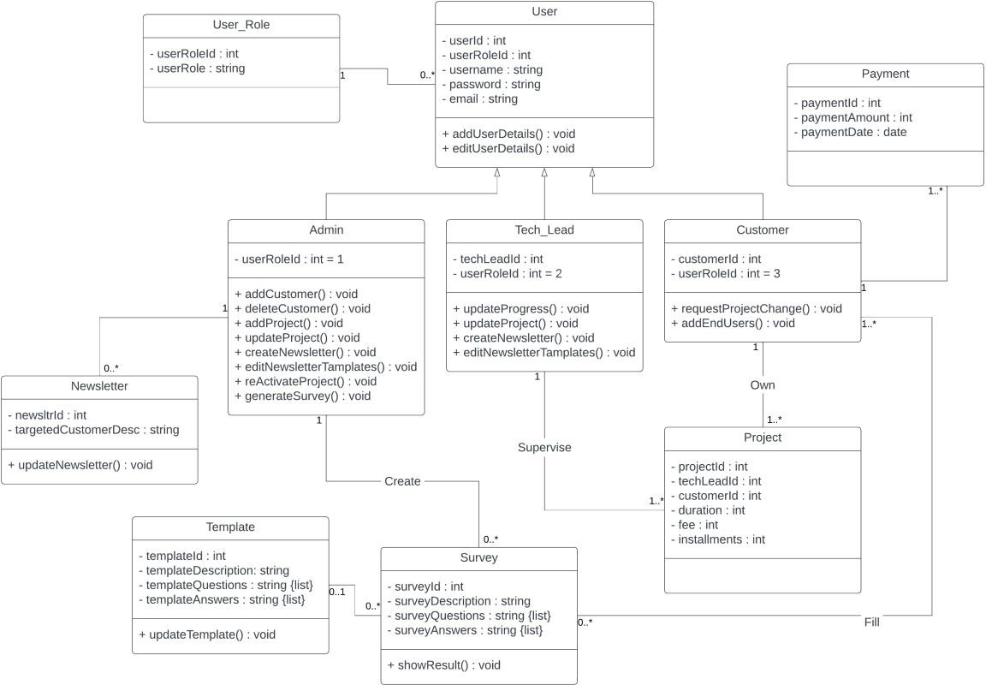

#### Sequence Diagrams

*Figure 13: Class Diagram*

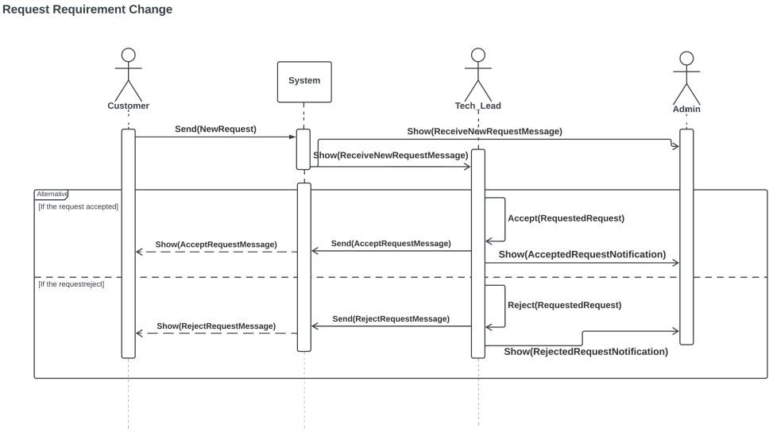

*Figure 14: Sequence Diagram - Request Changes*

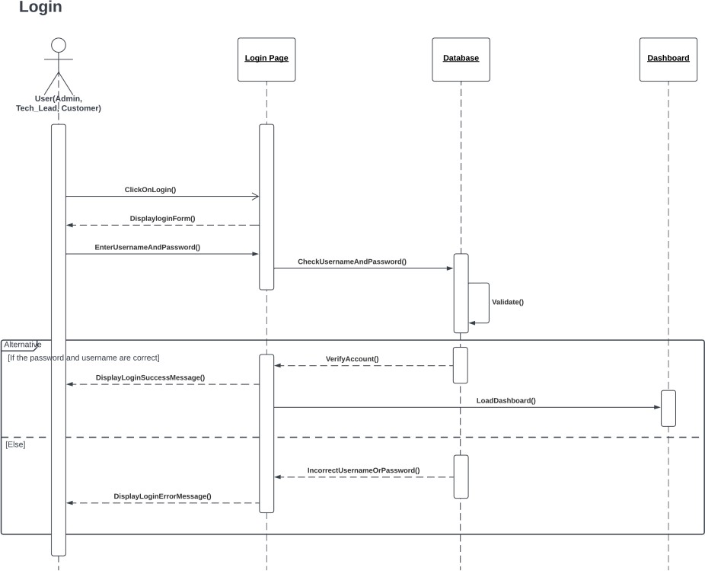

*Figure 15: Sequence Diagram - Login*

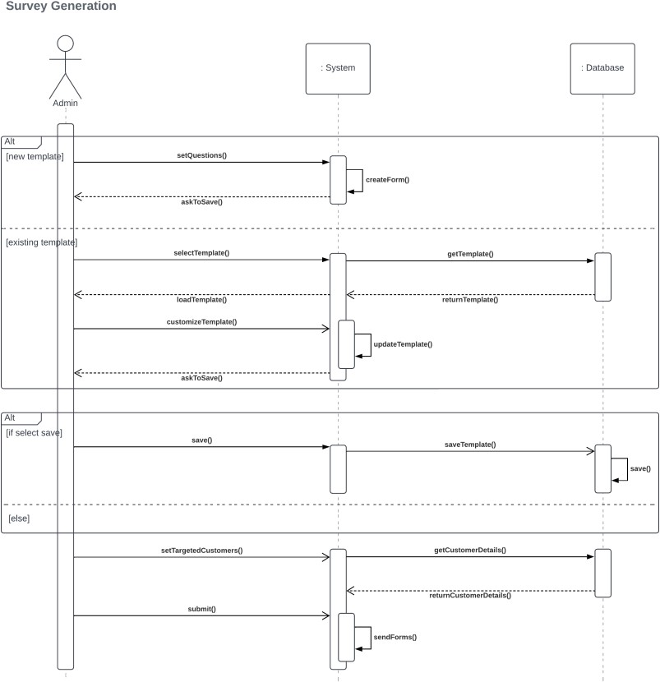

*Figure 16: Sequence Diagram - Survey Generation*

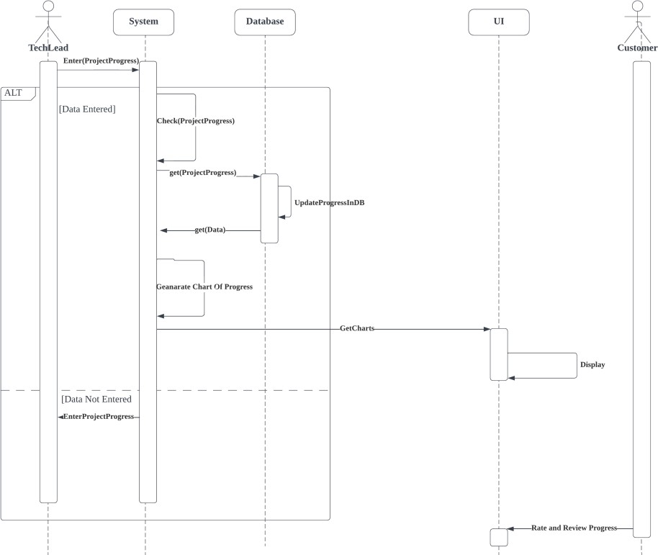

*Figure 18: Sequence Diagram - Progress Update*

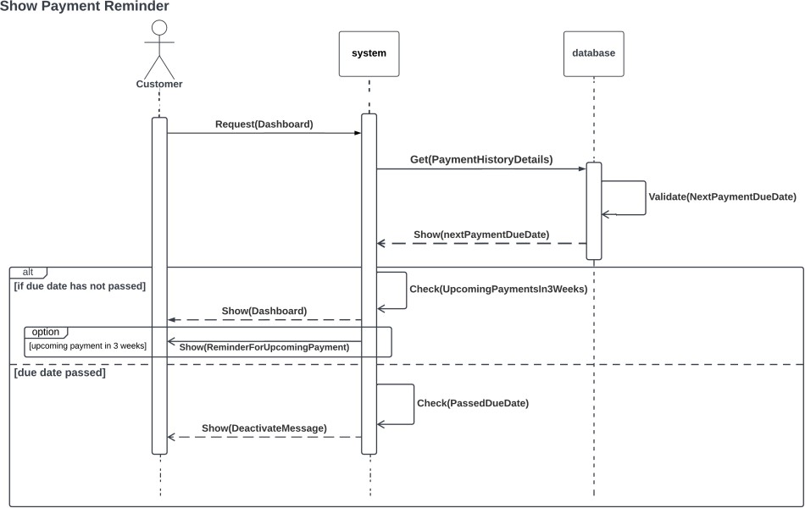

*Figure 17: Sequence Diagram - Show Payment Reminders*

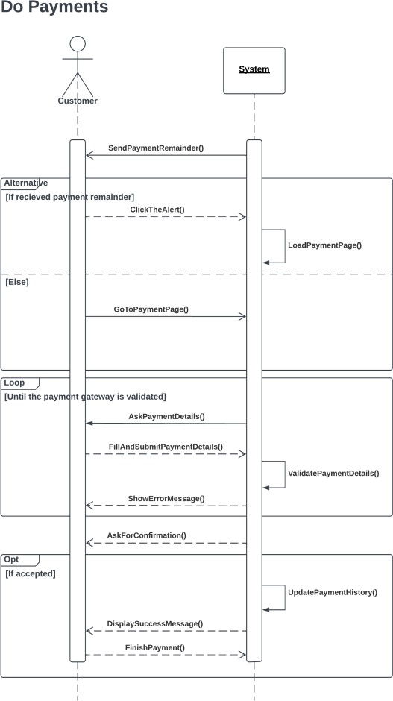

*Figure 19: Sequence Diagram - Do Payments*

#### ER Diagram

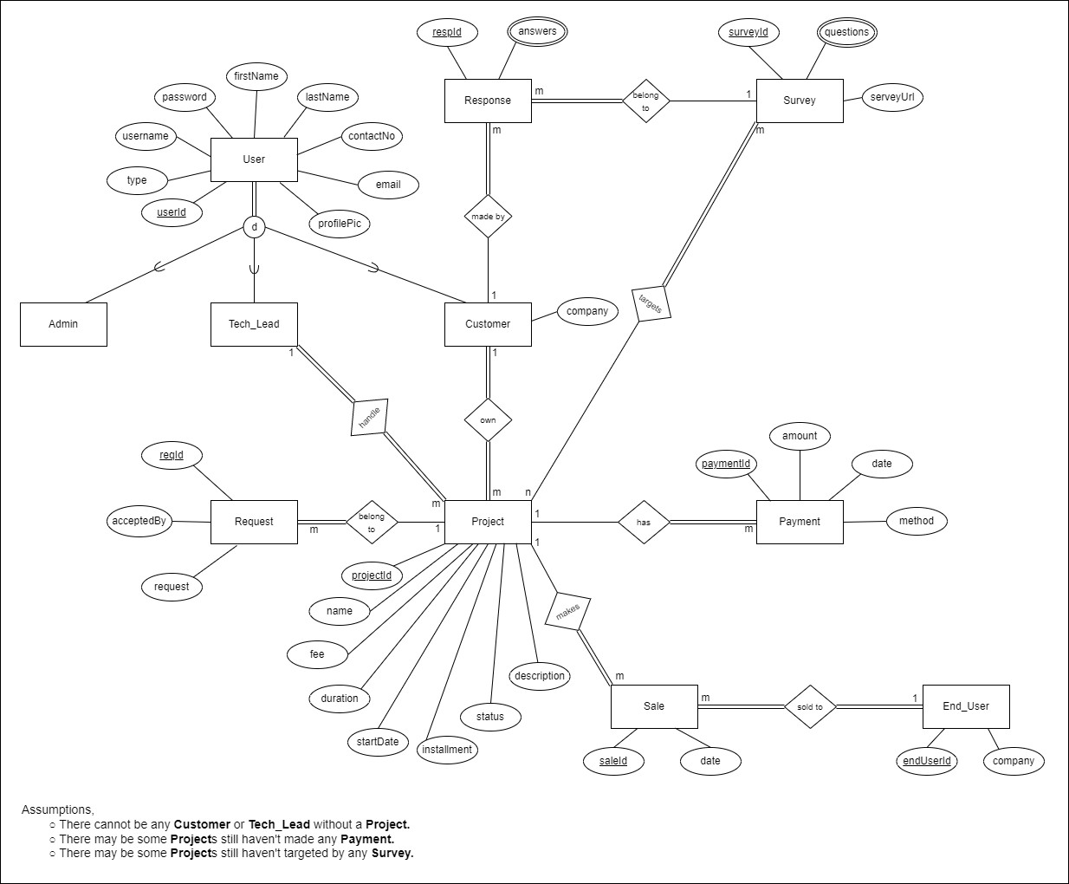

*Figure 20: ER Diagram*

### Chapter 6 – Implementation

#### Login page

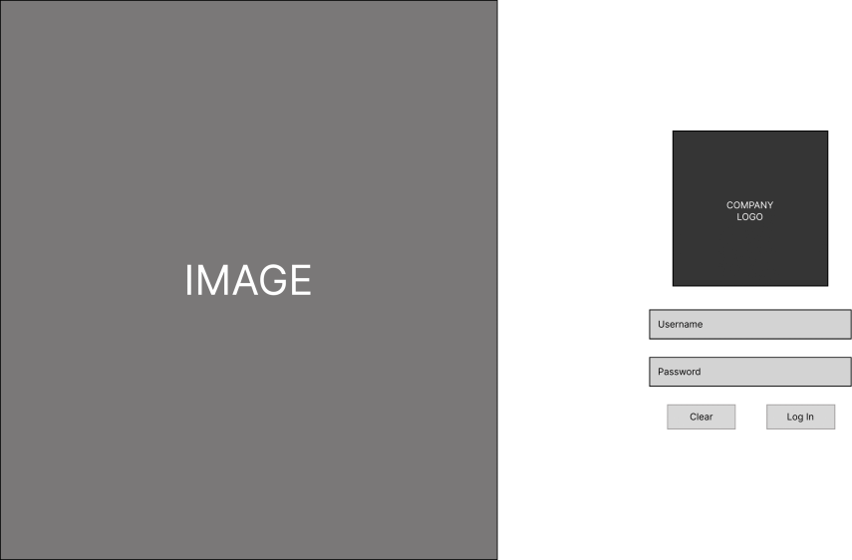

*Figure 21: Login Page*

#### Administrator’s Dashboard

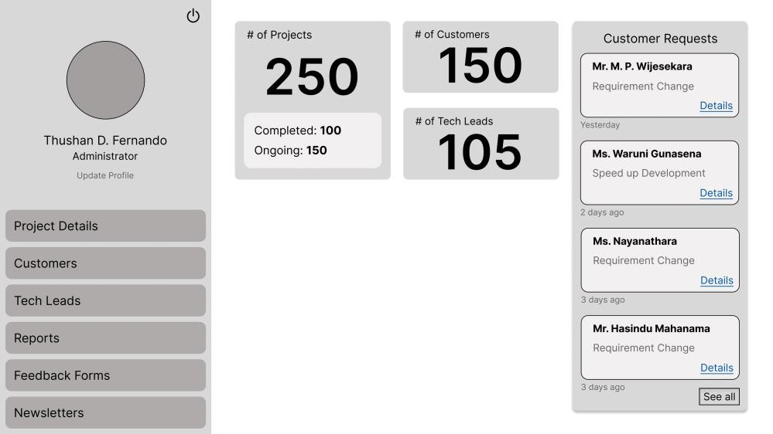

*Figure 22: Dashboard - Admin*

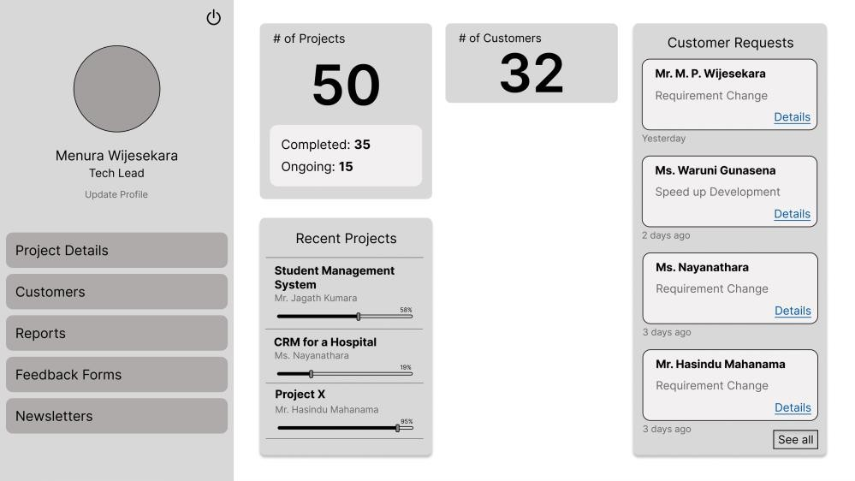

*Figure 23: Dashboard - Tech Lead*

#### Customer’s Dashboard

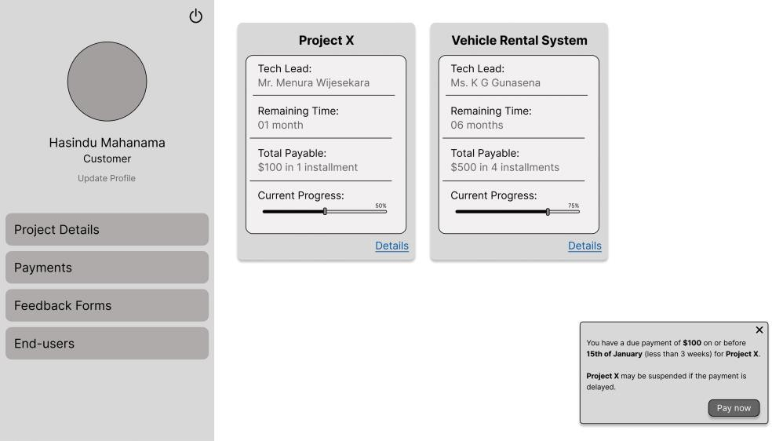

*Figure 24: Dashboard - Customer*

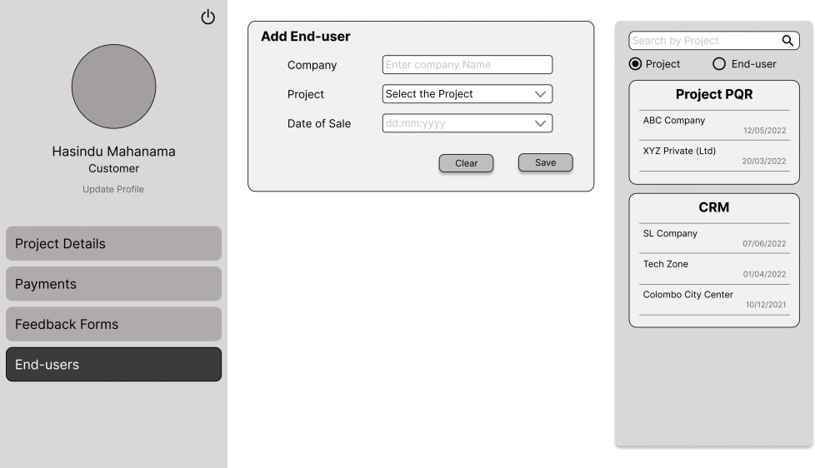

*Figure 25: End user management 1*

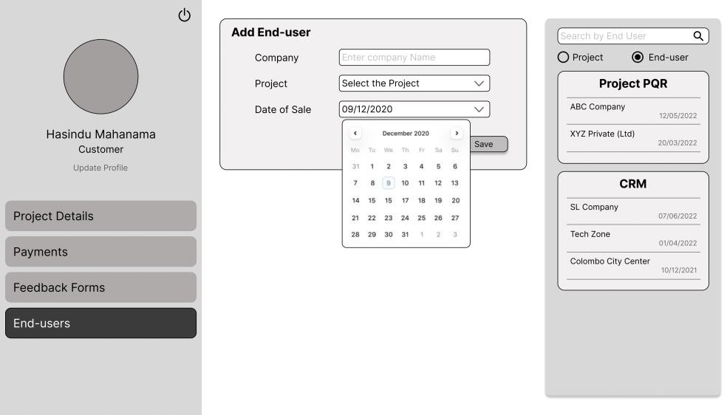

*Figure 26: End user Management 2*

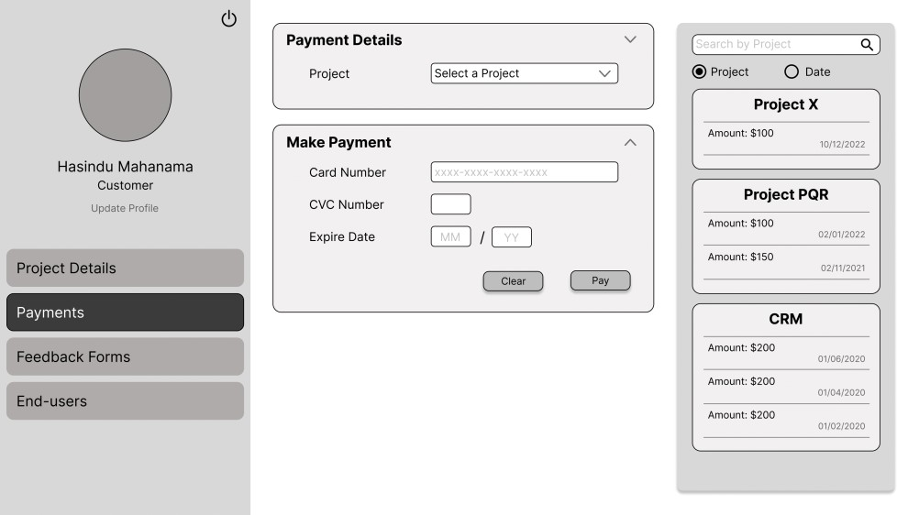

*Figure 27: Payments 1*

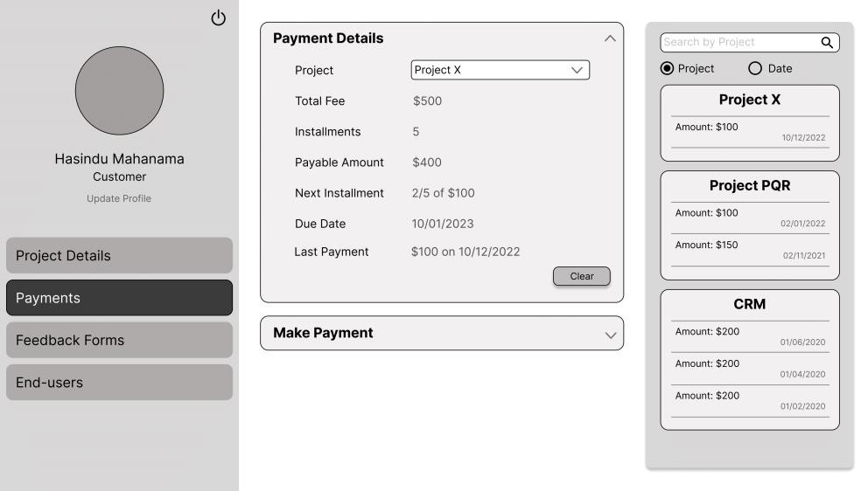

*Figure 28: Payments 2*

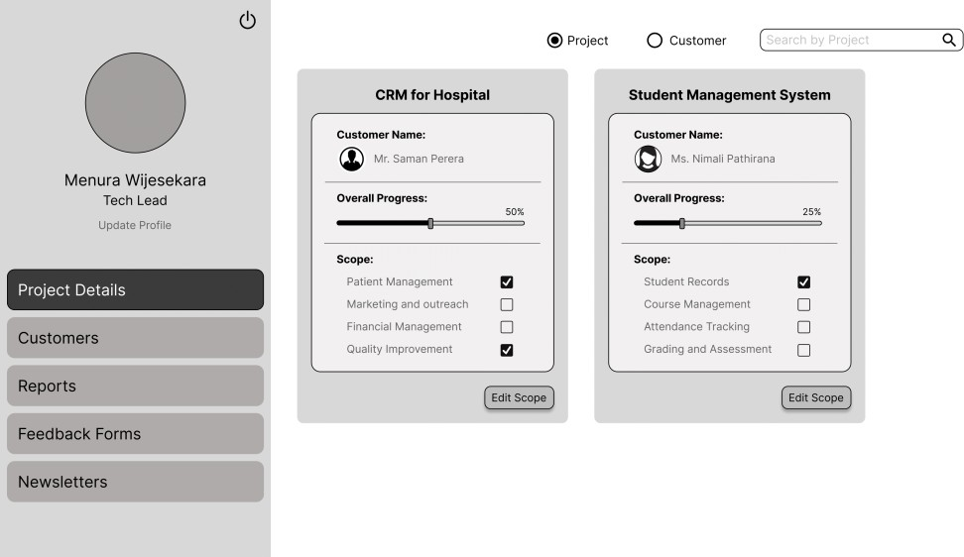

*Figure 29: Project Details - Tech Lead*

#### Customer’s Project detail view

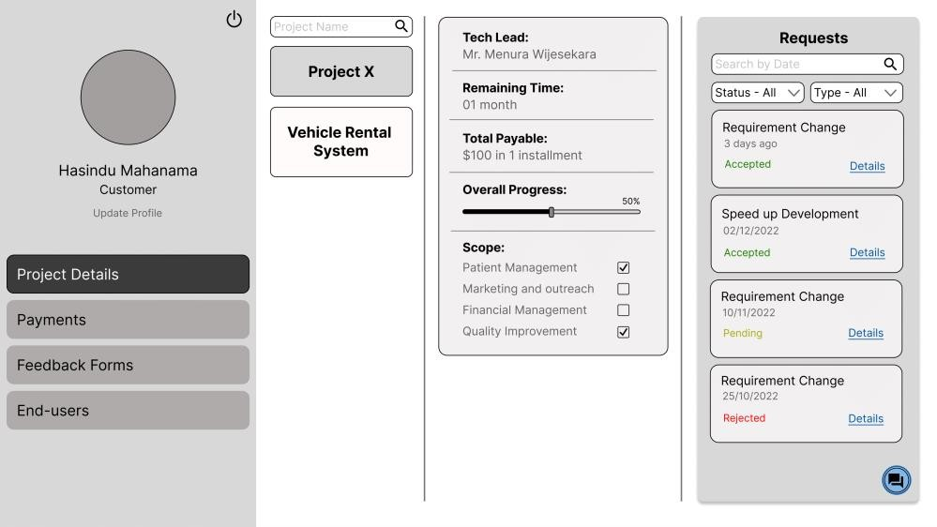

*Figure 30: Project Details 1 - Customer*

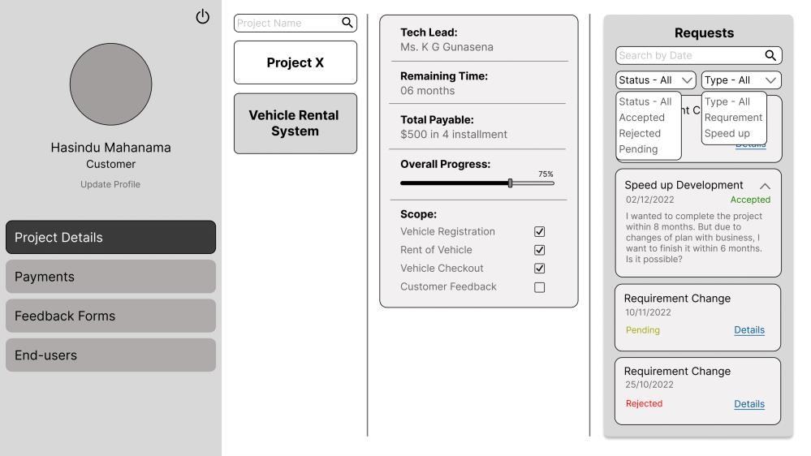

*Figure 31: Project Details 2 - Customer*

#### Administrator’s Customer Feedback Form responses option view

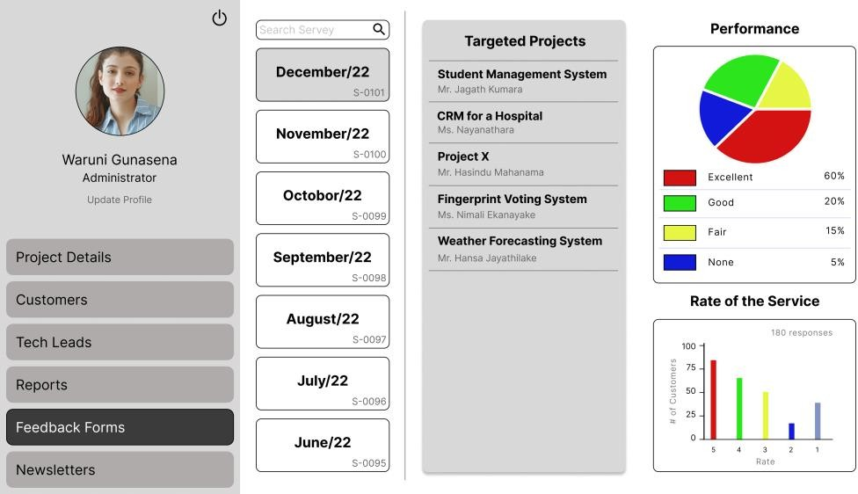

*Figure 32: Feedback Form Results*

#### Add user/project option

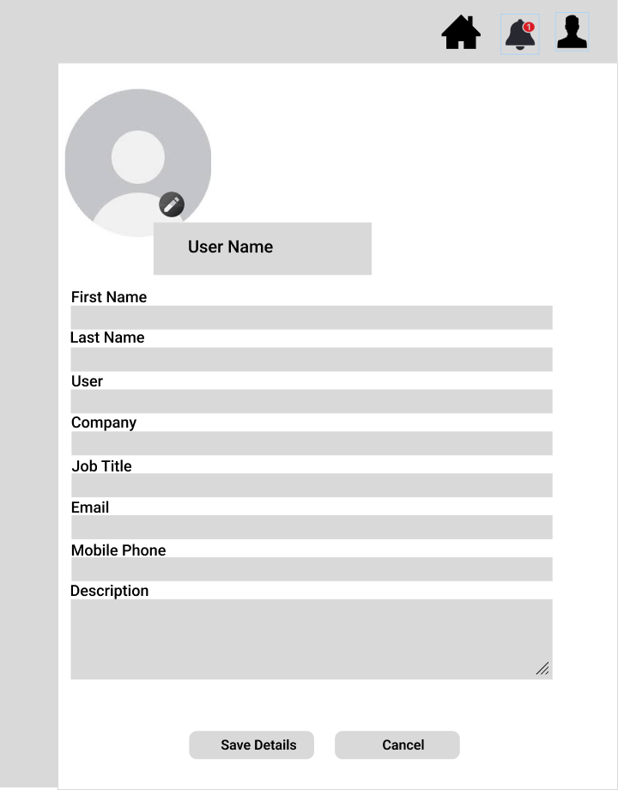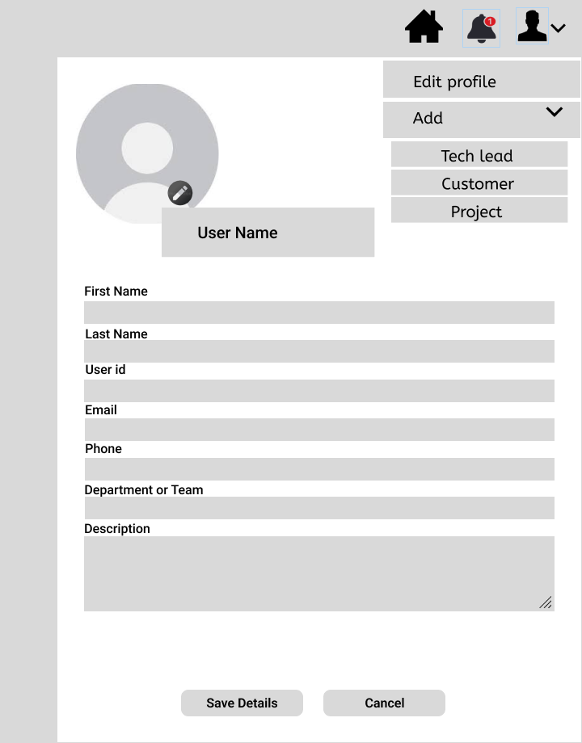

*Figure 33: Add Tech Lead Figure 35: Add Project*

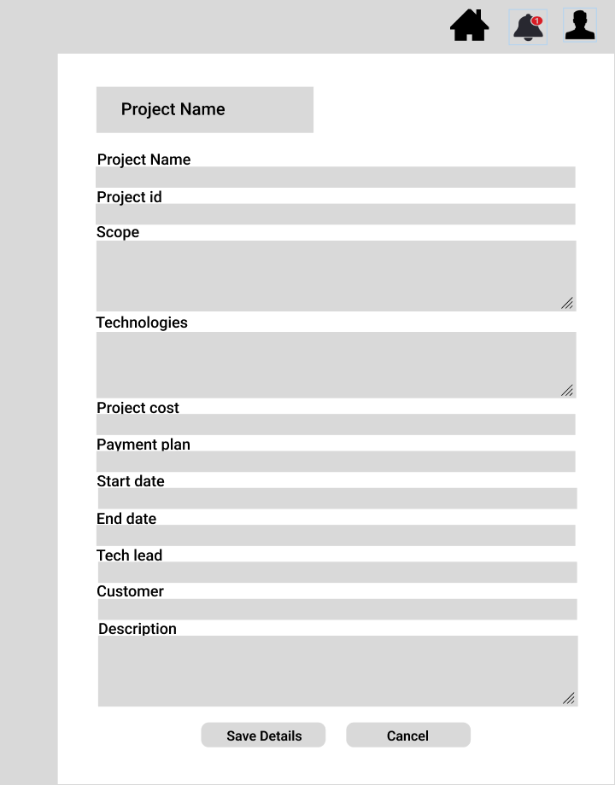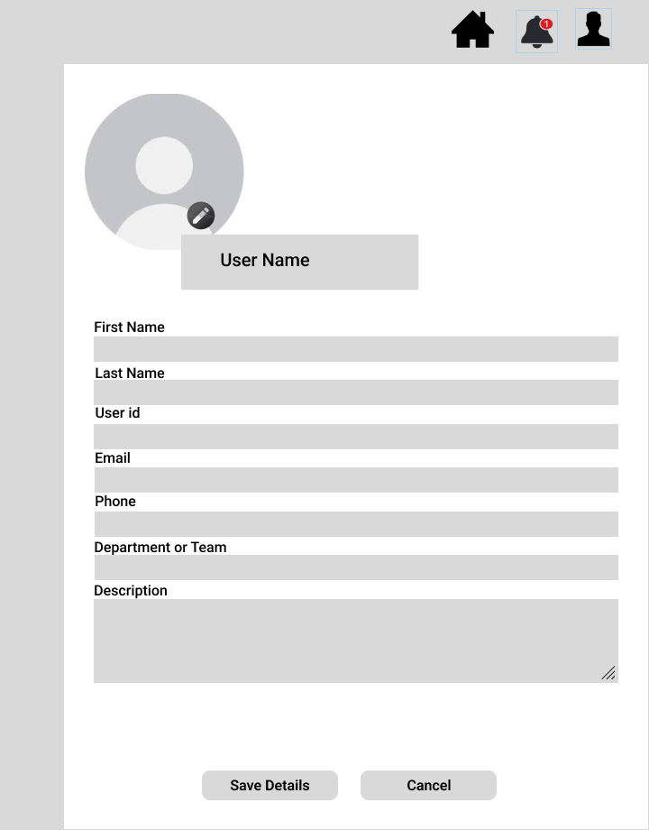

*Figure 34: Add Customer Figure 36: Add Admin*

#### Chat interface view

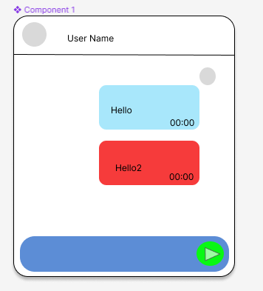

*Figure 37: Chat Bot*

### Chapter 7 - Discussion

#### Introduction

This chapter briefly discusses the evaluation and testing of our project, how our solution differs from similar works done by others, and the further work of our project.

#### Evaluation and testing

As we are still in the early stage of creating our project, we have not yet conducted any evaluations or tests on any part of it. This means currently we have not assessed the functionality, reliability, or any other performance.

#### How our solution differs from similar works done by others

There are many CRM systems available in the market, and most businesses are using these systems to maintain good interaction with the customer. Click Up, HubSpot, and Pipedrive are some examples of the most used CRM systems. Apart from the common features that can be seen in these existing systems, in our system, there are some additional features like survey generation and result dashboard, performance management, simple user interface, newsletters and reports, and upcoming payment reminders.

#### Further Work

As further work, we must develop the front-end, back-end, and database of our system. For that, we use React JS, .NET, and Microsoft SQL, respectively. Also, we need to integrate the project management software used by the company to get real-time updates on the project’s progress. And then we need to create and maintain a form for survey generation, for that we can integrate it with google forms or if required can create a form. Also need to develop email generation, notification system, chat service, and project management as per the requirements. For project management, we are using slack software. We need to integrate a payment gateway to allow online payments. For this, we can use secure payment gateways such as PayPal according to the client’s recommendations.

#### Summary

This chapter highlights some key points that were discussed in the previous chapters. That concludes the evaluation and testing and similar systems in the market. And explained the further work that we must do.

|  |  |
| --- | --- |
| [1] | E. Golightly, “10 best CRM software examples and their use cases,” *ClickUp*, 18- Nov-2022. [Online]. Available: <https://clickup.com/blog/crm-software-examples/>. [Accessed: 01-Jan-2023]. |
| [2] | “ReactJS Tutorial - javatpoint,” [*www.javatpoint.com*.](http://www.javatpoint.com/) [Online]. Available: <https://www.javatpoint.com/reactjs-tutorial>. [Accessed: 01-Jan-2023]. |
| [3]  . | “NET,” *Microsoft*. [Online]. Available: <https://dotnet.microsoft.com/en-us/>. [Accessed: 01-Jan-2023]. |
| [4] | *Keap.com*. [Online]. Available: <https://keap.com/product/what-is-crm>. [Accessed: 01-Jan-2023]. |
| [5] | “MS SQL Server Tutorial,” *Tutorialspoint.com*. [Online]. Available: <https://www.tutorialspoint.com/ms_sql_server/index.htm>. [Accessed: 01-Jan- 2023]. |

#### 204053A - Fernando K.T.D

The proposed solution is CRM software, and it has many divided modules. Followings are my responsibilities,

* + - Managing end-user details
    - Showing upcoming payment reminders
    - Integration of payment gateway
    - Managing the payment History

#### Managing end-user details

The 99x is a software developing company and their products will be sold to other companies for reselling purposes. Details of customers of 99x are recorded in CRM software. Also, the sales information of each product developed by 99x sold to end-users by customers of 99x should be recorded. For example, ABC company is a customer and Project X is developed by 99x. Project X is sold to XYZ company by ABC company. Records of this sale should be kept in the proposed CRM software.

#### Showing upcoming payment reminders

Customers of 99x may have several projects ongoing and they may have installments to pay. A key feature of CRM software is to remind the payments to each customer if the due date is less than 3 weeks. If the payment due date is passed, then CRM software should lock the customer’s functions for regarding project. Also, system admins must be able to reactivate the functions.

#### Integration of payment gateway and Payment History

Payments for each project should be handled by CRM software using a payment gateway. And the users must be able to view the transaction history for each payment.

Currently I am working on the Managing end-users' part and other parts are not started yet. But I designed all the interfaces for my responsible parts.

#### 204233C - Wijesekara M.P

Our software is a CRM system helping to ease the communication between the customer and developers. My contribution in the system is to develop the Chat system and survey generation system.

When considering the chat system, it will be the basic communication platform used in the system to communicate between customer and developer or admin. In the system, we have a system where customers can request changes to the ongoing project. To facilitate this, we are using the chat system. The customer can simply send the request through the chat and then it will be considered as a request.

When sending a request through chat we are trying to use a chat bot. When the customer sends a message through the special request button the chat bot will be activated and then it will ask about the request from the customer. The title will be requested, and when the customer sends it as a message, it will be used to create the request in the admin, developer, and customer interfaces where it will be displayed as pending requests.

I am planning to encrypt the messages and save them in the database, and we will provide the facility of choosing the receiver, sending messages, deleting messages, and viewing messages with the deliver and read status. I am studying Signal R since we are using .NET framework and since Signal R is a FOSS library and searching for similar APIs to create the chat system.

For the survey generation part, I am planning to integrate Google form to the system and get the responses to an Excel sheet and then save them to the database for future use. By using Google forms, it will be easy for us to analyze the data and create chats related to the forms. Through that we can easily create and analyze the responses and present them in a descriptive way for the management for future decision making.

This is my contribution to the system, and I am still studying them.

#### 204039L - Dilanka M.G.G.H.

I am responsible for developing the report generate part and performance management part with project handle for CRM system.

First, I looked at and assessed a few existing CRM systems, looked at the report generation and performance management sections, and noted the benefits, drawbacks, and areas that may use improvement. I planned the feature's scope after determining the requirements.

I used Git version controller with GitHub. Since I am not familiar with it, I studied and worked with it before we started development. so that every group member can easily update the code without any hassle.

I contributed with the EER diagram, use case diagram, class diagram, activity, and sequence diagrams, which improved my comprehension of the system.

I started utilizing the Figma tool to create the UI/UX designs for the features for which I am responsible in accordance with the design concepts we as a team decided on.

Since we are using React.js to develop the front-end of our application, I started by consulting some tutorials and YouTube videos. Additionally, take a React.js course on Udemy. About two weeks after studying React, I started development by initiating a React project.

Additionally, we are using the MS.NET framework to construct the backend, and I am taking a course on MS.NET to learn and begin developing the project report generation part.

Aside from that, we will start using Microsoft SQL Server as our database technology and start studying Microsoft SQL Server.

#### 204063E - Gunasena K.G.W.C

I am responsible for developing the survey result dashboard after the survey generation for each individual project's performance and for sending newsletters to customers through the CRM system.

First, I studied and analyzed some existing CRM systems, surveyed dashboards about varying platforms, and identified their pros, cons, and things to be improved. After identifying the requirements, I planned the scope of my feature and designed the sample interfaces for the survey result dashboard using Figma.

I contributed to drawing the EER diagram, use case diagram, class diagram, and activity and sequence diagrams for these features, which helped me further understand the system. According to the design ideas we decided on as a team, I started creating the UI/UX designs for the features that I am responsible for using the Figma tool.

Since we are building the front-end of our application using React.js, I referred to some tutorials and YouTube videos to start my part. And follow an Udemy course for React.js.

And, to develop the backend, we are using the MS.NET framework, and I am following a course on MS.NET to learn and start developing the survey result dashboard and the newsletter sending system. In addition, we will use Microsoft SQL Server technology as our database technology and start referring to Microsoft SQL Server

#### 204183V - Samarakkody S.T.R.H.N.

I am responsible for developing the login functionality, and the user information management service for the CRM system.

When a user logs into the system, they should enter their username and password. When the user submits the form, the system should verify the user’s password. If the details are not matched with any records, it should redirect to the login page.

The admin has the responsibility for adding the users (tech leads and customers) to the system. Also, he is the one who adds the projects. For the three users and the projects, there are four different profiles.

At the very first, we found some existing CRM systems and study about them to get an idea of the basic functionalities, advantages, and disadvantages of the system, and what features should be added.

Then we started drawing the use case diagram, class diagram, activity diagrams, sequence diagrams, and the EER diagram for the system. It helped me to better understand the system by visually representing the relationships and interactions.

After that, I started designing UI/ UX designs using the Figma tool, for the parts that I have responsibility for.

To start my part, I have watched some YouTube videos to study React because we are using React for the front-end development of our system. For the back-end development, we are using the .NET framework. So, I have started studying .NET also, by watching YouTube videos. We are using Microsoft SQL to design and implement the database for our application. So, I have started studying that as well.

### Appendix B – Action Plan

|  |  |  |  |  |  |  |  |  |  |
| --- | --- | --- | --- | --- | --- | --- | --- | --- | --- |
| **Task** | **2022** | | | | **2023** | | | | |
| Sep | Oct | Nov | Dec | Jan | Feb | Mar | Apr | May |
| Learning about Technologies |  |  |  |  |  |  |  |  |  |
| Requirements Analyzing |  |  |  |  |  |  |  |  |  |
| Database Design |  |  |  |  |  |  |  |  |  |
| UI Design |  |  |  |  |  |  |  |  |  |
| Database Development |  |  |  |  |  |  |  |  |  |
| Build the Solution |  |  |  |  |  |  |  |  |  |
| Testing |  |  |  |  |  |  |  |  |  |
| Implementation |  |  |  |  |  |  |  |  |  |

# Software Requirements

**Specification**

**for**

# CRM Software

**Version 1.0 approved**

**Prepared by group Quinary (Group 29)**

**Faculty of Information Technology**

**University of Moratuwa**

**24/12/2022**

## Table of Contents

**Table of Contents ii**

1. **Introduction 2**
   1. Purpose 2
   2. Document Conventions 2
   3. Intended Audience and Reading Suggestions 2
   4. Product Scope 2
   5. References 3
2. **Overall Description 4**
   1. Product Perspective 4
   2. Product Functions 4
   3. User Characteristics 5
   4. Operating Environment 5
   5. Design Development and Implementation Constraints 5
   6. Assumptions and Dependencies 6
3. **External Interface Requirements 7**
   1. User Interfaces 7
   2. Hardware Interfaces 7
   3. Software Interfaces 7
   4. Communications Interfaces 7
4. **System Features 8**
   1. System Initialization 8
   2. Admin’s Operations 8
   3. Customer’s Operations 9
   4. Tech Lead/Project Lead ‘s Operations 10
   5. Chat Service 11
   6. Form creation 11
5. **Other Nonfunctional Requirements 12**
   1. Performance Requirements 12
   2. Safety Requirements 12
   3. Security Requirements 12
   4. Software Quality Attribute 13
   5. Business Rules 13

## Introduction

### Purpose

This document describes the external interface requirements, system features, and non-functional requirements of the proposed Customer Relationship Management (CRM) system.

### Document Conventions

The IEEE standard was utilized in the composition of this software requirements specification document. The headings and subheadings in this document were formatted in bold type, and the citations were written using the "Times New Roman" style.

### Intended Audience and Reading Suggestions

This SRS document will be helpful for all the users of the CRM system (Admin, tech leads, customers), developers, and testers to get an idea about the functionalities of the system.

It is recommended to users refer to the product’s overall description and to developers and testers go through the external interface requirements, system features, and other non-functional requirements.

### Product Scope

Having a good relationship with customers is crucial for the long-time success and viability of a business. To manage and maintain these relationships effectively, a company may use a CRM system. This system is a tool that helps businesses track and manage interactions with customers, including communication, sales, and service-related activities. By using a CRM system, businesses can improve their customer relationships, increase customer satisfaction and loyalty, and drive sales and revenue growth.

So, our aim is to develop Customer Relationship Management Software to manage customer interactions within the business including key features such as,

* Keep a record of Customer information and map them with the relevant projects.
* Keep a record of Sales History and give updates about ongoing projects.
* Send reminders about upcoming Payments and newsletters.
* Keep track of the payments made.
* Address the request regarding the projects.
* Track customer satisfaction regarding the work done.
* Generate detailed reports required for the company and customer regarding the project performance.
* Get Customer feedback

### References

IEEE 830-1998 standard for writing SRS document

## Overall Description

### Product Perspective

CRM software is an application that manages the customers and developer relations in terms of the project. Here the customer can get real time updates about the project from the system and rate it according to his/her wish.

One of the main purposes of the system is to ease the viewing of project progress for the customers, as the system will be an all-in-one platform to view progress, rate progress and facilitate all sort of customer interactions required for the progress of the project from start to end.

Also, the system allows the customer to communicate with the admins and project leads easily thorough the system and makes it efficient and cost effective to communicate.

This application is only available as a web application.

### Product Functions

1. Admin logs into the system and create Customer account (if not exist)
2. Admins create the Project page
3. Admin connects the project page with the Customer Account
4. Admins assigns a Project-Lead to the project
5. Customer logs in to the system and change his/her password
6. Project Lead update the Progress of the project
7. Customer View the Project Progress
8. Customer do requests to do changes for the system
9. Admin or Project lead Accept or Reject the requests
10. Admin and Project lead Generate monthly surveys
11. Customer answers the Monthly surveys
12. Charts for the results will be generated
13. Admin and Project lead Reviews the results
14. Customers receive payment reminders
15. Customer View Payment History and due payments
16. Customer do online payments through the gateway
17. Admin update the payment history
18. If payment not done on time admin deactivates the project and reactivates after payment receive
19. Admin creates the Newsletters
20. Customers receive Newsletters
21. Admins generate the reports monthly
22. After project completion project status will be updated to ‘Complete’
23. Customers need to update them about the sales made.

### User Characteristics

There are three users for the project Admins, Project leads and Customers. Not much knowledge about the technology is required for the use of the system. Basic click and views are used in the interfaces.

### Operating Environment

The tool can run on any machine that has windows, Mac or Linux operating system and a stable internet connection.

### Design Development and Implementation Constraints

* Front end will be designed by React JS
* Back end will be handled by .NET framework
* Microsoft SQL will be used to manage the databases
* Azure web services will be used as the cloud system
* A payment gateway will be integrated to make online payments through the system
* A chat system will be used to implemented to facilitate communication within the system
* Google forms will be integrated for the Survey generation part
* Project management tool, integration will be done to update the progress.

### Assumptions and Dependencies

The Customer Relationship Management System will be helpful for the customer to track the progress of his/her projects in real time.

All the users of the system should be connected to the internet for proper functioning of the system.

## External Interface Requirements

### User Interfaces

* + 1. **Login**

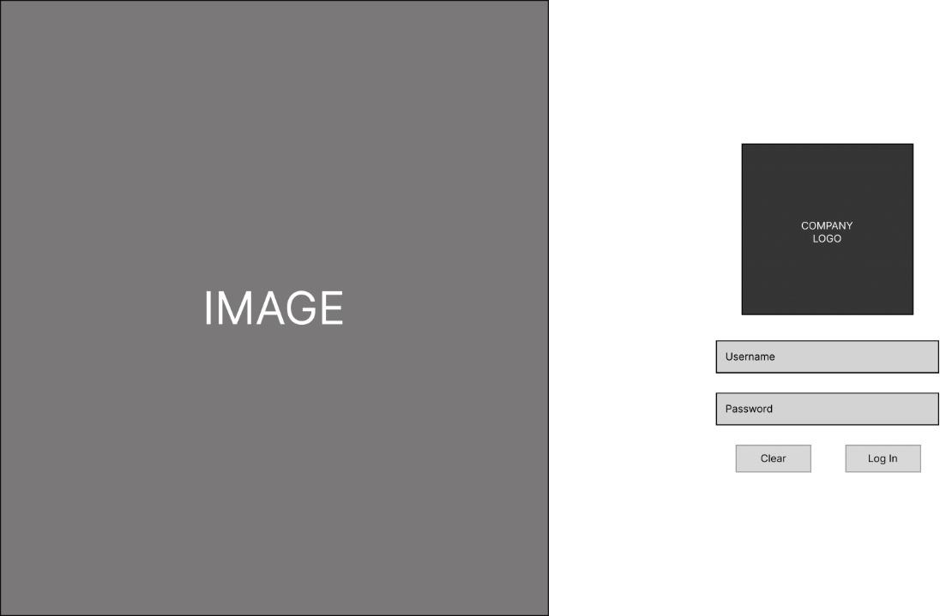

* + 1. **Profile – Admin 3.1.3 Profile – Tech Lead**



**3.1.4 Profile – Customer 3.1.5 Profile – Project**



* + 1. **Dashboard-Admin**

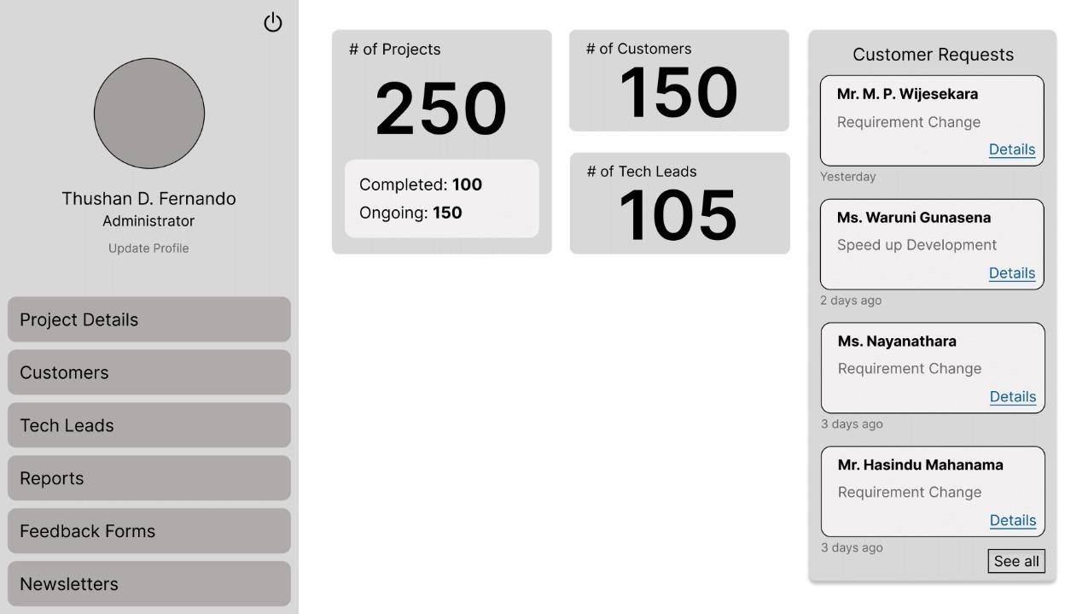

* + 1. **Dashboard-Tech Lead**

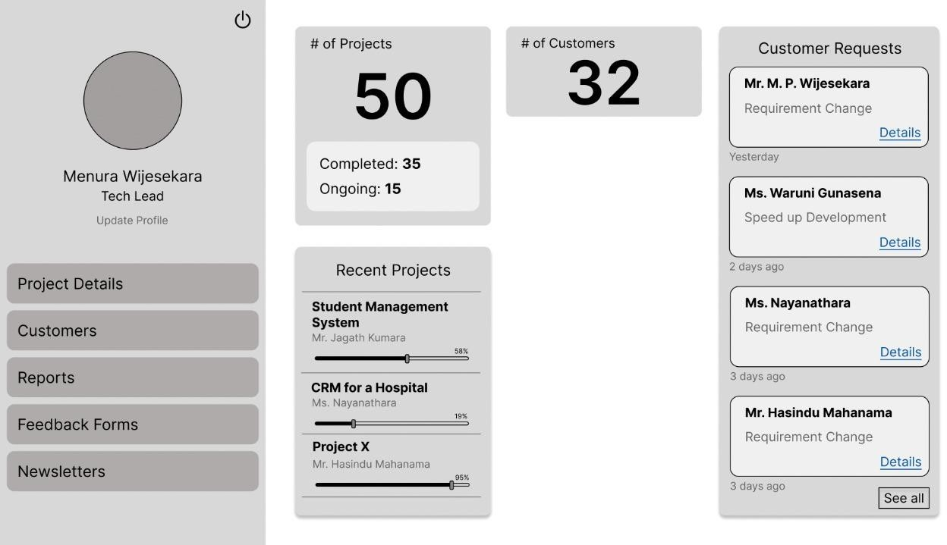

* + 1. **Dashboard Customer**

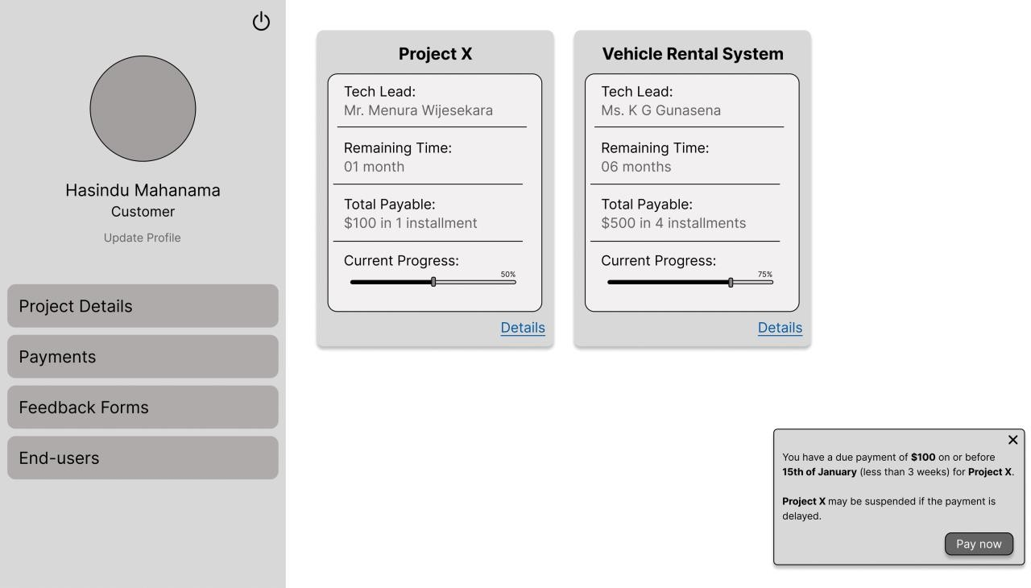

* + 1. **Payments1-Customer**

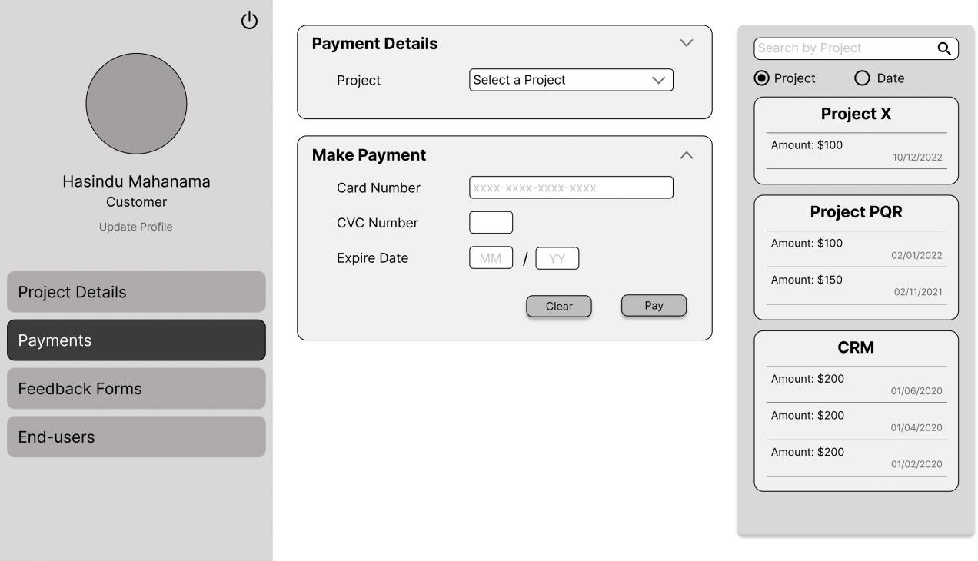

* + 1. **Payments2-Customer**

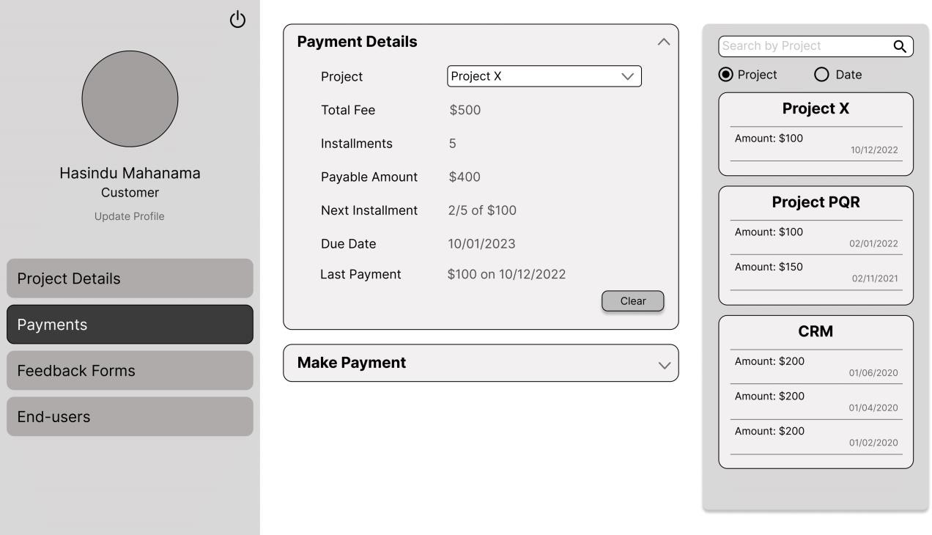

* + 1. **EndUser1-Customer**

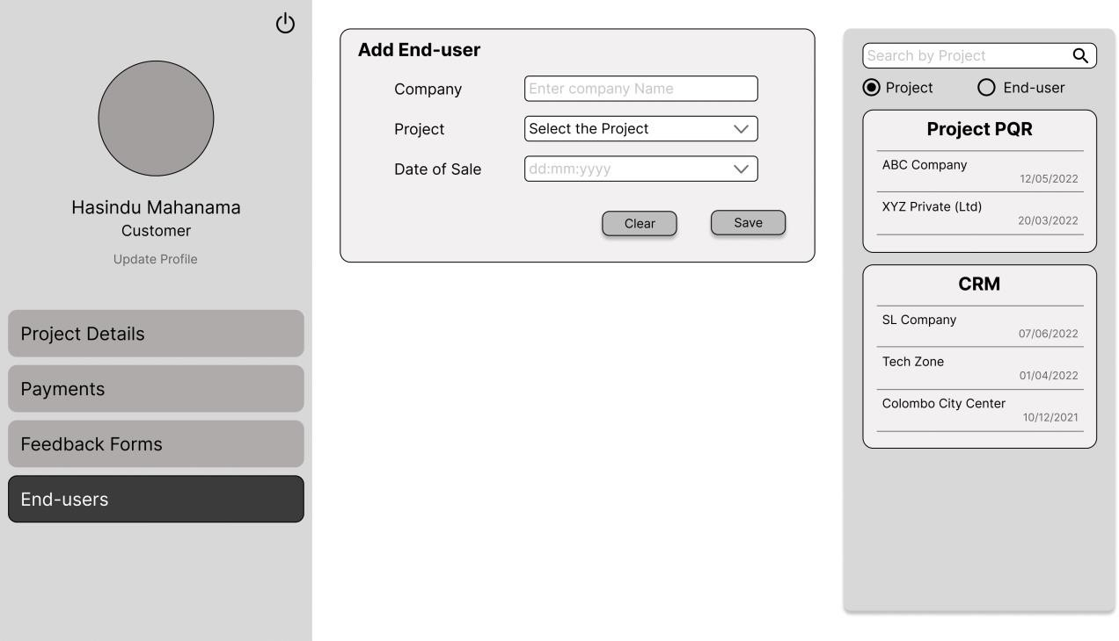

* + 1. **EndUser2-Customer**

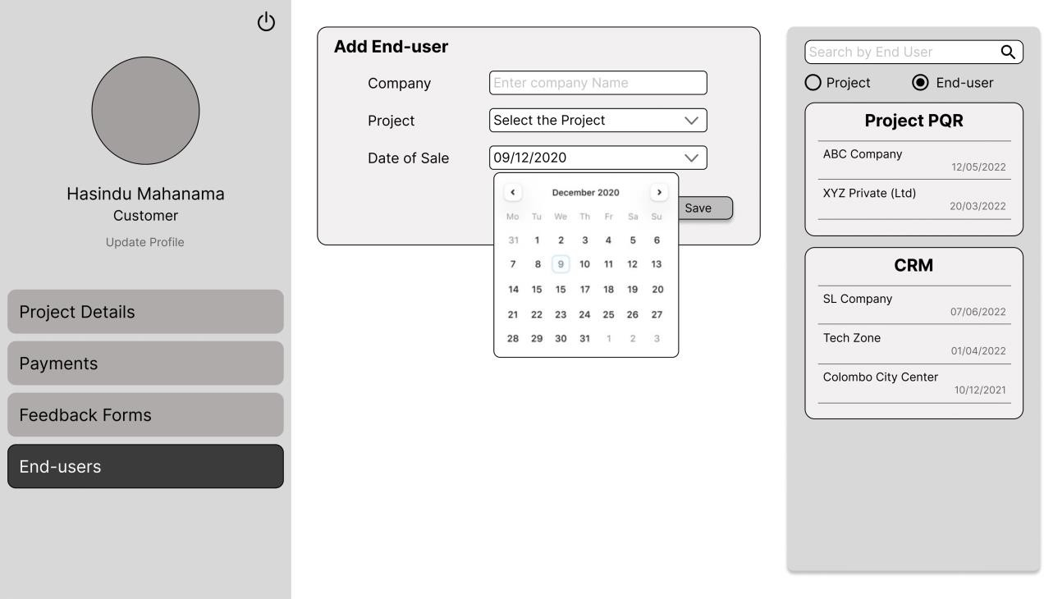

* + 1. **Project Details – Tech Lead**

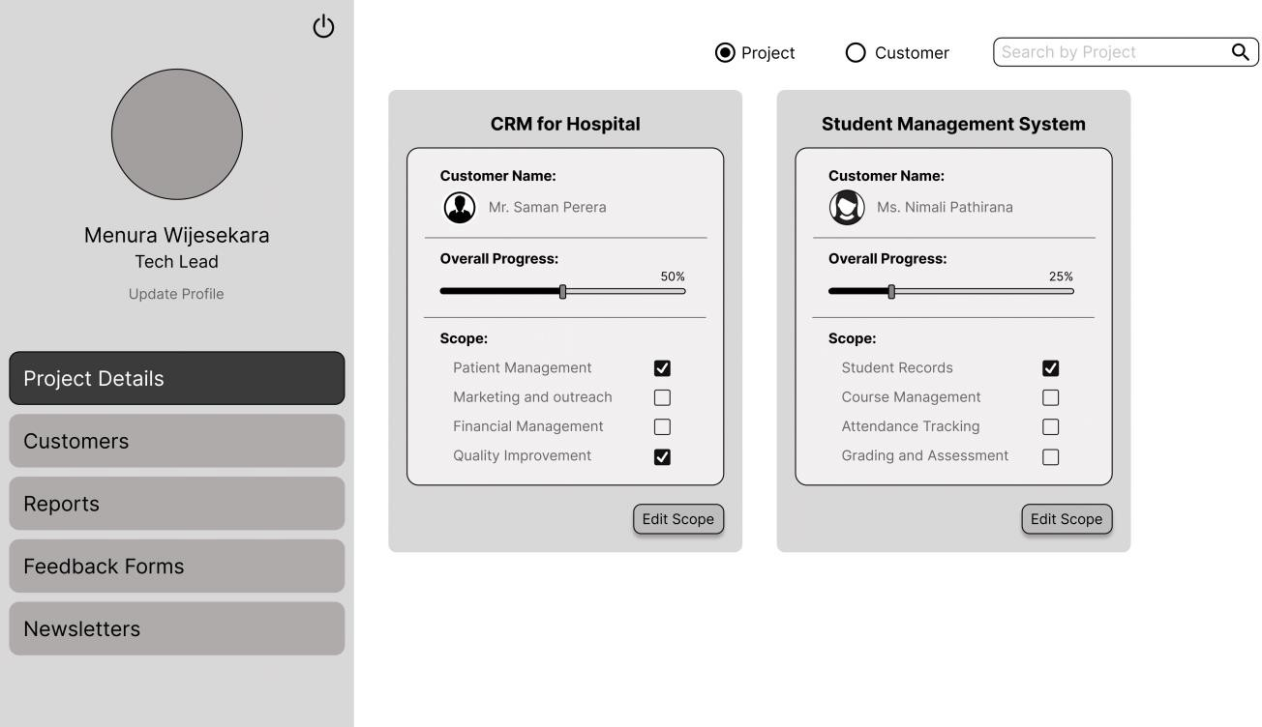

* + 1. **Project Details 1 – Customer**

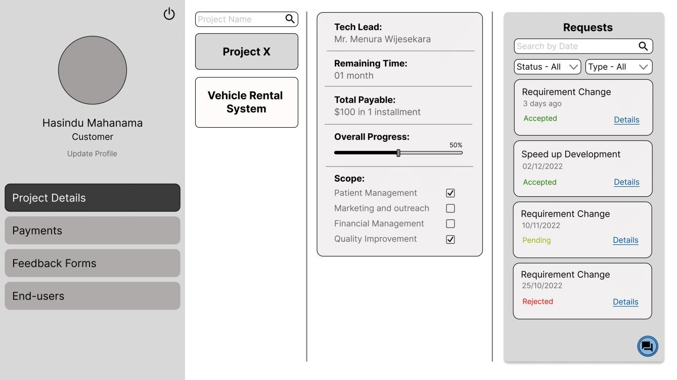

* + 1. **Project Details 2 – Customer**

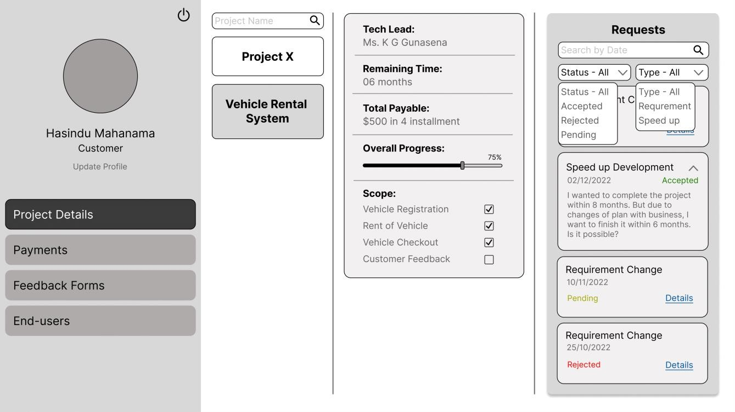

* + 1. **Survey result dashboard**

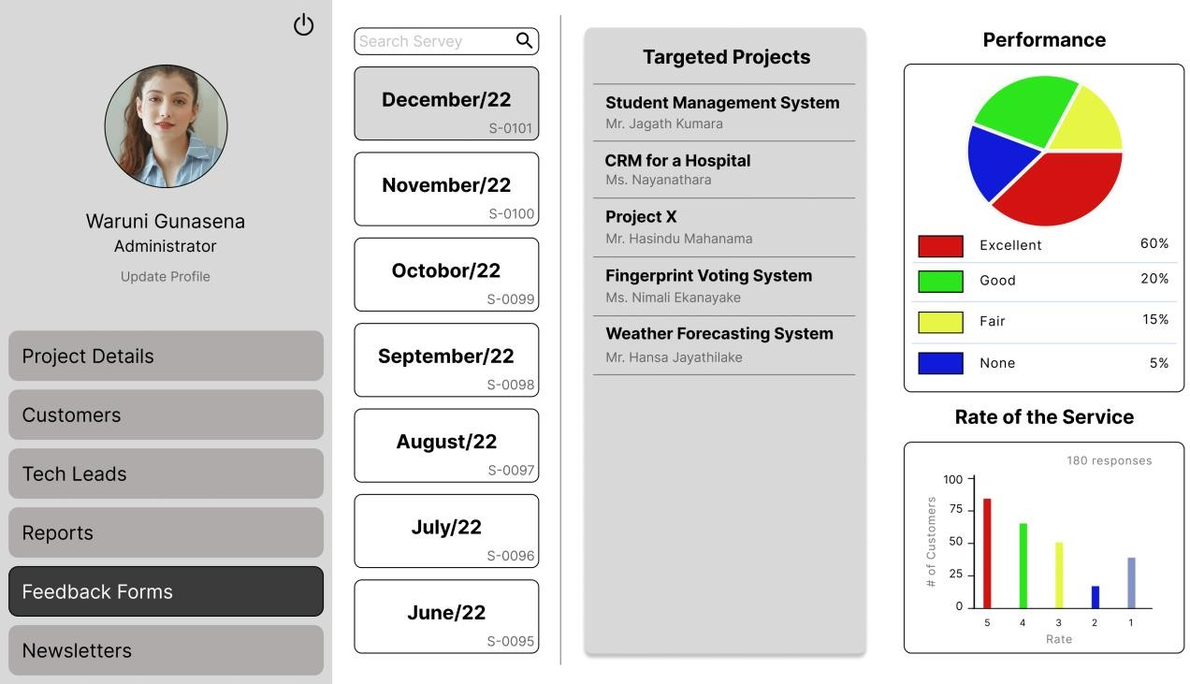

### Hardware Interfaces

* PC or a Laptop
* Wi-Fi Router
* Dongle

These hardware components will be sufficient to finish the system. This system will be created as a web-based application. Every device may therefore work with any web browser, enabling uninterrupted data access for this system. No specific internet connection, more CPU, or GPU processing power are needed for this approach. It is feasible to process data normally. As a device depends on a certain hardware specification for routine browsing, it will be the least hardware requirement for running this software.

### Software Interfaces

Various technologies are used to create software interfaces. They can be divided into the following categories.

* Front-end technology - React JS
* Back-end technology - MS .NET framework
* Database technology - MS SQL Server

### Communications Interfaces

An internet connection is required to stay connected to the application and get the benefit of its functionalities.

## System Features

This illustrates organizing the functional requirements for the product by system features, the major services provided by the product. We can divide the functional requirements into the following categories.

### System Initialization

#### Description

The following functional requirements are concerned when the user logs into the system. The system users have restrictions on view. Whenever a user logs into the system, it should perform the login methodology depending on the type of user.

#### Functional Requirements

REQ 1: The system should load the UI based on his/her user type. REQ 2: The user can edit the Details.

### Admin’s Operations

#### Description

The admin personally must create the customer account and the project page, and then connecting the customer account with the project page is done by the Admin. The admin has the responsibility of generating surveys, generating reports, creating newsletters, addressing customer requests, update about the project progress, analyzing survey results, assigning a project lead, reactivate projects, update payment history, view sales history and viewing payment details about a project.

* + 1. **Functional Requirements** REQ 1: Create Customer account REQ 2: Create Project page

REQ 3: Connecting customer account with project page

REQ 4: Generate Surveys REQ 5: Generate Reports REQ 6: Create Newsletters

REQ 7: Address Customer Requests REQ 8: Update payment History REQ 9: Reviewing Survey results REQ 10: Assigning a Project lead REQ 11: Reactivating Projects

REQ 12: Extending time for payment REQ 13: View Sales History

REQ 14: Sending Newsletters REQ 15: Using chat service REQ 16: View Project Status

### Customer’s Operations

#### Description

The Customer is the key personal who is benefitted from the system. As a customer, he/she is responsible for viewing the Project progress, filling customer surveys, making payments and similar things related to the projects.

* + 1. **Functional Requirements** REQ 1: Viewing Project Progress REQ 2: Filling Customer Surveys REQ 3: Rating Progress

REQ 4: Requesting Changes

REQ 5: Doing online Payments REQ 6: Updating Sales History REQ 7: Viewing Payment history

REQ 8: Receiving Payment reminders REQ 9: Receiving Newsletters

REQ 10: Viewing Due Payments REQ 11: Using Chat Service REQ 12: Editing Profile Details REQ 13: View Project Status

### Tech Lead/Project Lead ‘s Operations

#### Description

As the person responsible for the development part of the project Tech lead or Project lead has the responsibility of updating the project progress, generating surveys, reviewing survey responses and similar activities connected to the project development side.

* + 1. **Functional Requirements** REQ 1: Updating Project Progress REQ 2: Generate Surveys

REQ 3: Generate Reports

REQ 4: Reviewing Survey Results REQ 5: Addressing Customer Requests REQ 6: View sales History

REQ 7: Using Chat Service REQ 8: View Project Status

### Chat Service

#### Description

Chat service is used to ease the communication between the Customer and the Project lead or Admin. Here we use this to send messages and user requests.

#### Functional Requirements

REQ 1: Send messages REQ 2: Send requests

REQ 3: Choose the receiver (Admin or Project lead)

### Form creation

#### Description

We are using forms to get the customer feedback about the project’s progress throughout the month. Using this the customer will be able to rate the progress and give comments.

#### Functional Requirements

REQ 1: From Creation REQ 2: Question Creation REQ 3: Template saving REQ 4: Editing Templates REQ 5: Saving Results REQ 6: Analyzing Results

REQ 7: Report Generation about the results

## Other Nonfunctional Requirements

### Performance Requirements

* Basic operations must be finished in under 2 seconds.
* User interfaces should refresh fast while exploring the system.
* There are no instant delays in any action-response system.
* Less than 2 seconds pass between saving settings and error messages appearing.
* The web application and the SQL database must communicate with the system.
* The SQL database must have the ability to expand.
* In a typical workload, the CPU should not be used more than 50% of the time.

### Safety Requirements

Data should be securely sent to the server without being altered.

* The application may identify all its client applications before allowing any of them to access its features.
* Authentication and authorization mechanisms should be used.
* Within 10 seconds, at least 99 per cent of intrusions must be identified.

The system's data needs to be regularly backed up in case a restore is necessary in an emergency. The maintenance policy is assessed to reduce interference with user activity.

### Security Requirements

Each user should log in to the system using credentials provided by the company at the time of registration. Users would not be authorized to create accounts.

payment security,

Payment gateway systems are used for this CRM. Overall, payment gateways are an essential component of online payment systems, providing a secure and convenient way for merchants to accept payments from customers. (Encryption, Authentication, Firewalls, and Security protocols)

### Software Quality Attribute

#### Usability

* + - * The user will not need any training to operate the system because of the way the interfaces have been designed.
      * The interfaces will be simple to use and labelled, and a help menu with instructions for performing fundamental operations will be available.
      * The system can be accessed using devices with any size screen because it is platform independent.

#### Maintainability

* + - * The system code should be developed in such a way that future updates are conceivable.
      * The code will be well commented.

### Business Rules

Systems for managing and improving customer and client interactions are known as customer relationship management (CRM) systems. The requirements and objectives of the firm will determine the business rules for a CRM system. However, a CRM system might also integrate a few basic business principles.

**Data management:** Business policies governing how consumer data is handled, including how it is gathered, stored, and used, as well as any applicable privacy laws and regulations.

**Lead management:** Rules for tracking and managing leads, including how to prioritize and follow up on leads, and when to pass them off to sales teams.

**Customer service:** Rules for handling consumer questions and complaints, including expected response times and contact methods.

## User stories

### Customer

As a customer

I want to Check Progress

So that I can know how my project is being progressed.

As a customer

I want to log in to the system So that I can use the system.

As a customer

I want to do online payments

So that I can get my project finished on time.

As a customer

I want to Check Payment History So that I can track my expenses.

As a customer

I want to see due Payments

So that I can allocate funds to do the payments.

As a customer

I want to receive payment reminders So that I can make payments on time.

As a customer

I want to Request Changes

So that I can get the product I want.

I want to Receive Newsletters

So that I can be updated about the development company.

As a customer

I want Give feedback about the progress So that I can show my satisfaction.

As a customer

I want to analyze the project Progress

So that I can be updated about my project’s progress.

As a customer

I want to log in to the system So that I can use the system

### Administrator

As an Admin

I want to log in to the system So that I can use the system

As an Admin

I want to create customer account

So that the customer can use the system

As an Admin

I want to create project page and join it with customer So that the customer can view project details

As an Admin

I want to address the requirement changes So that the project can progress smoothly

I want to review customer feedback

So that I know how satisfied the customers are.

As an Admin

I want to update project progress

So that customer will know about project progress

As an Admin

I want to generate surveys

So that I collect customer feedback

As an Admin

I want to update payment history

So that customer will know about his payments

As an Admin

I want to view payment history

So that I can get an idea about the payments received

As an Admin

I want to view balance payments

So that I can get an idea about the payments to be received

As an Admin

I want to generate reports

So that I can use them for decision making

As an Admin

I want to generate newsletters

So that customers will be updated about company’s work

### Project Lead

As a Project Lead

I want to log in to the system So that I can use the system

As a Project Lead

I want to address the requirement changes So that the project can progress smoothly

As a Project Lead

I want to review customer feedback

So that I know how satisfied the customers are.

As a project lead

I want to update project progress

So that customer will know about project progress

As a project lead

I want to generate surveys

So that I collect customer feedback

As a project lead

I want to view payment history

So that I can get an idea about the payments received

As a project lead

I want to view balance payments

So that I can get an idea about the payments to be received

As a project lead

I want to generate reports

So that I can use them for decision making

As a project lead

I want to generate newsletters

So that customers will be updated about company’s work